**AI Micro Degree Project Report**

NSTI Bangalore (General)

Name of the Students :

1. Aditya Kumar
2. Anand Kumar
3. Bhupender Singh
4. Gulshan Yadav
5. Nelaturi Shivababu
6. Payal Raj
7. Prateek Cheepa
8. Pramesh Tiwari
9. Sarthak verma
10. Shubham Chauhan
11. Varsha Sahu
12. Vikas Bharthi
13. Vinay S

Python :

**1)Student Report Card System -** This project allows users to add student details, enter or update subject-wise marks, and view individual report cards with calculated grades. It uses Streamlit for the interface and MySQL for data storage.

Some screenshots of the project done by the traine

* Add Student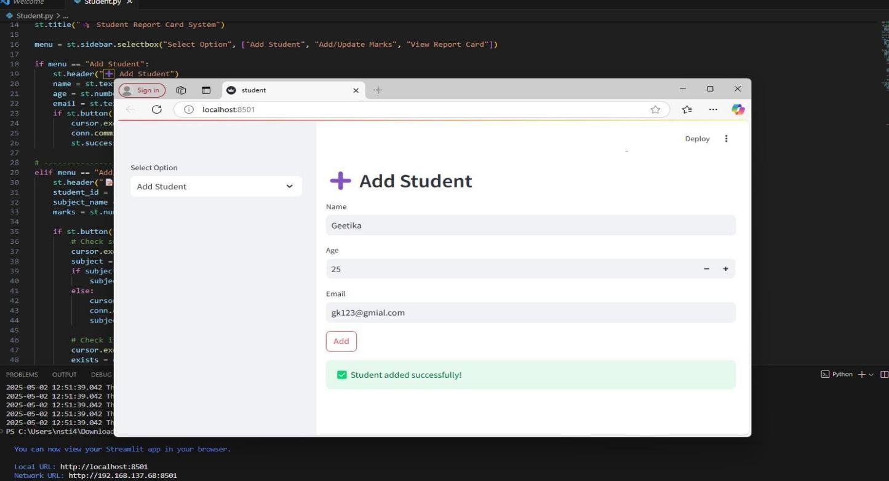
* Add/ Update Mark

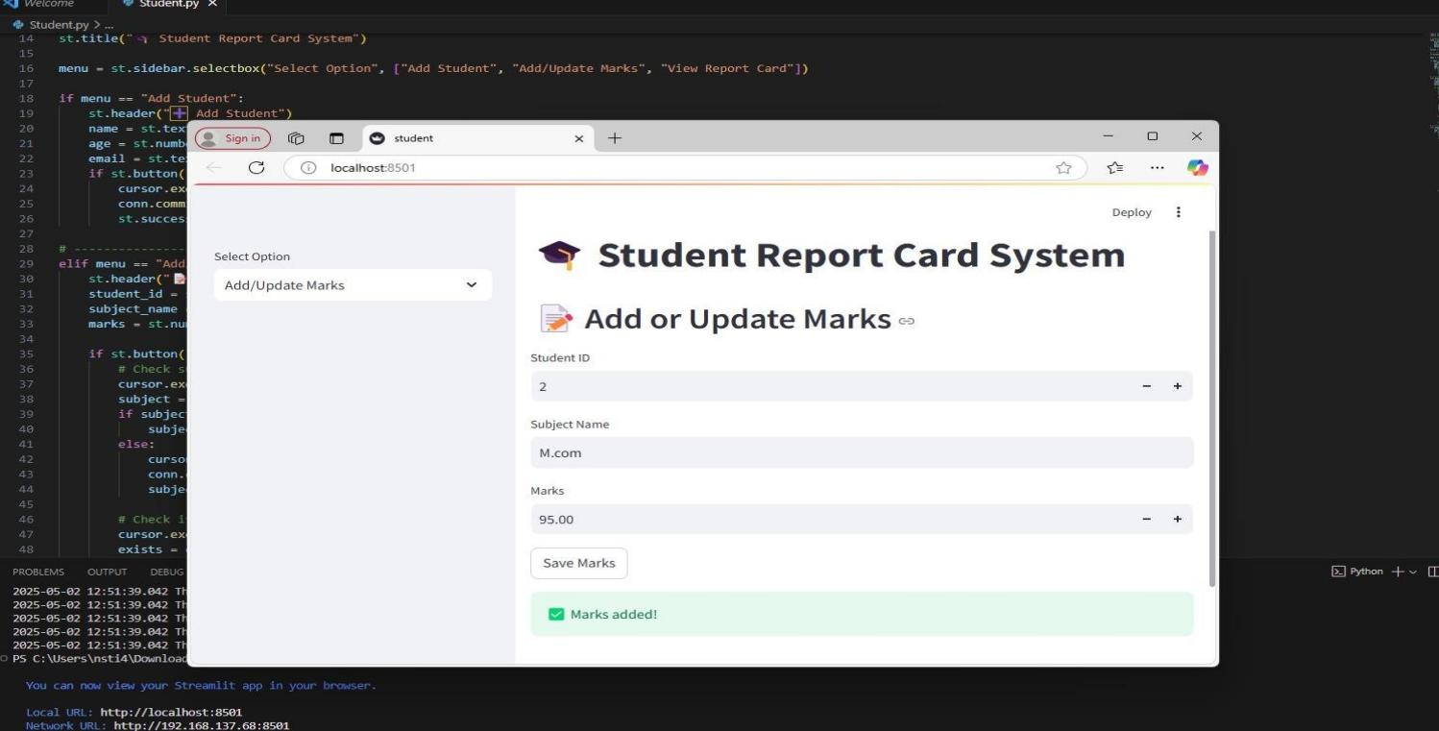

* View Report Card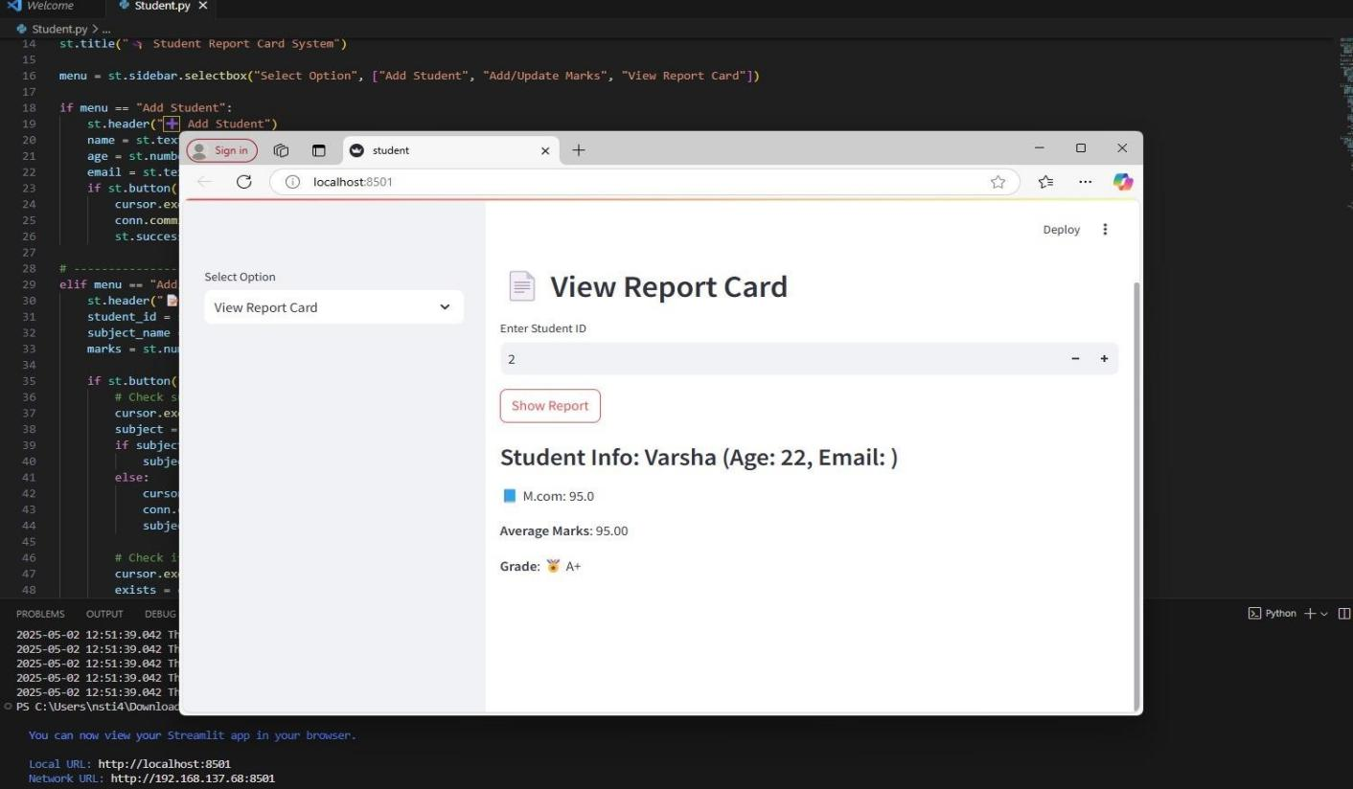

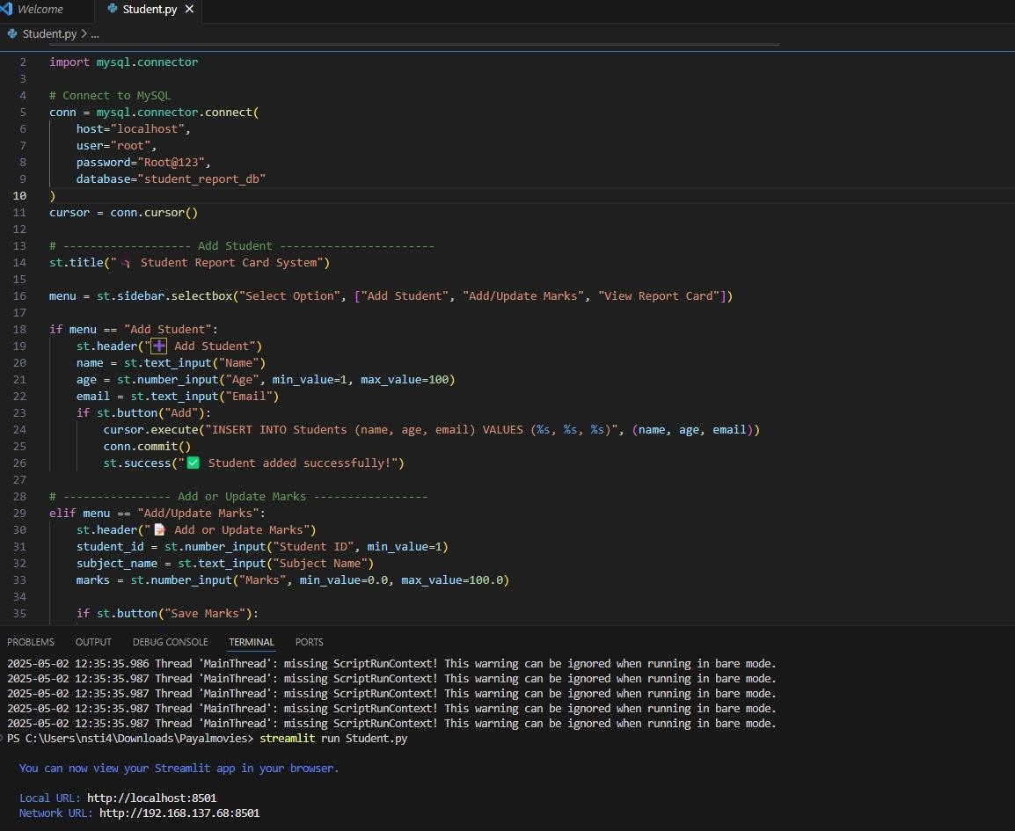

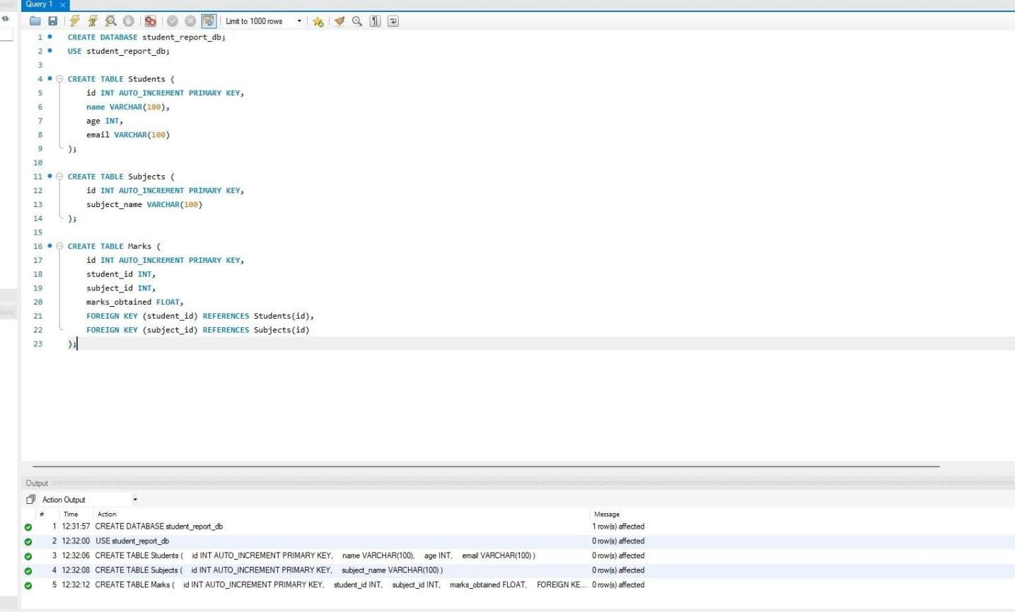

**2)Interactive Word Guessing Game using Python and Tkinter-** This project GUI-based word guessing game where players guess letters to reveal a hidden word.Built with Python and Tkinter, featuring styled interface, feedback system, and end-game popups.

Some screenshots of the project done by the trainees:

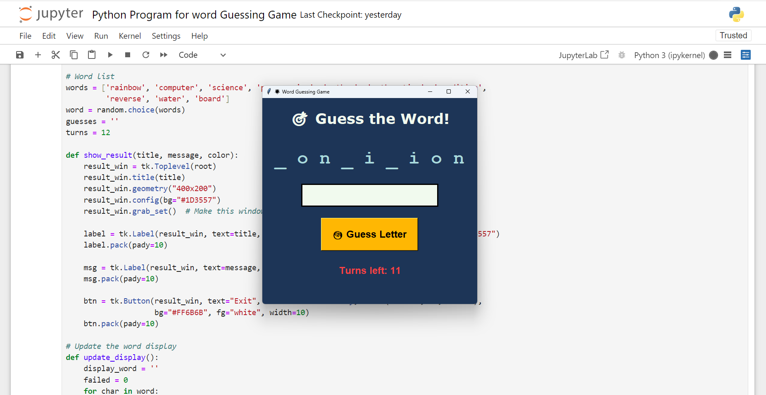

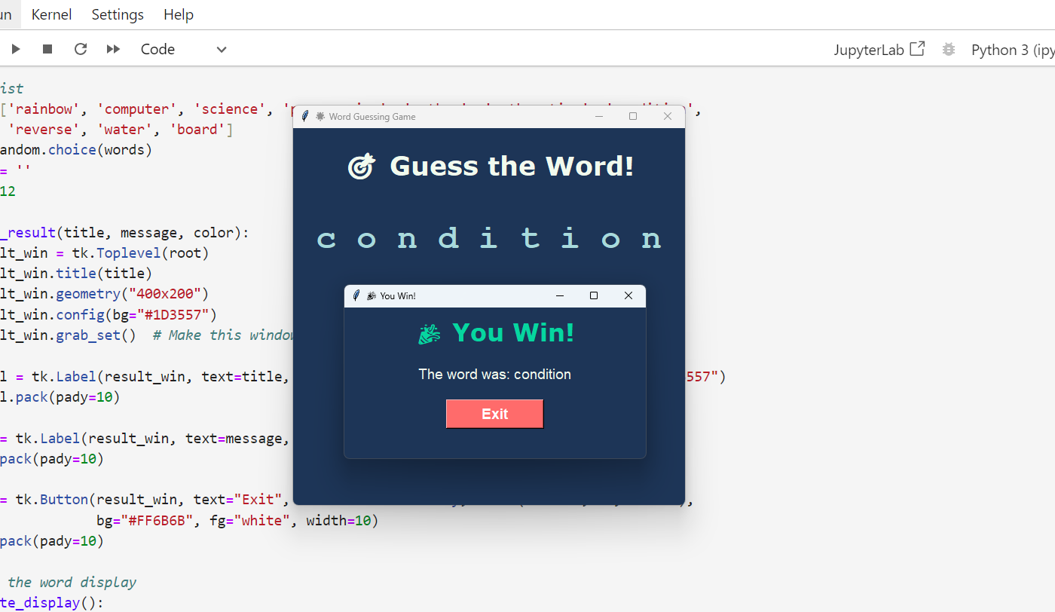

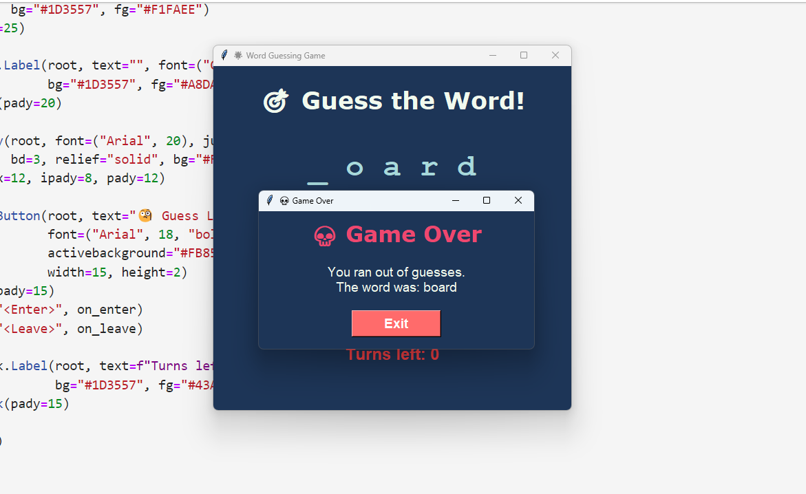

**3)Number Guessing Game with Tkinter-**  A GUI-based game where players guess a randomly chosen number within a range and limited chances.Built using Python and Tkinter, it features interactive input, real-time feedback, and game logic with reset functionality.

Some screenshots of the project done by the trainees:

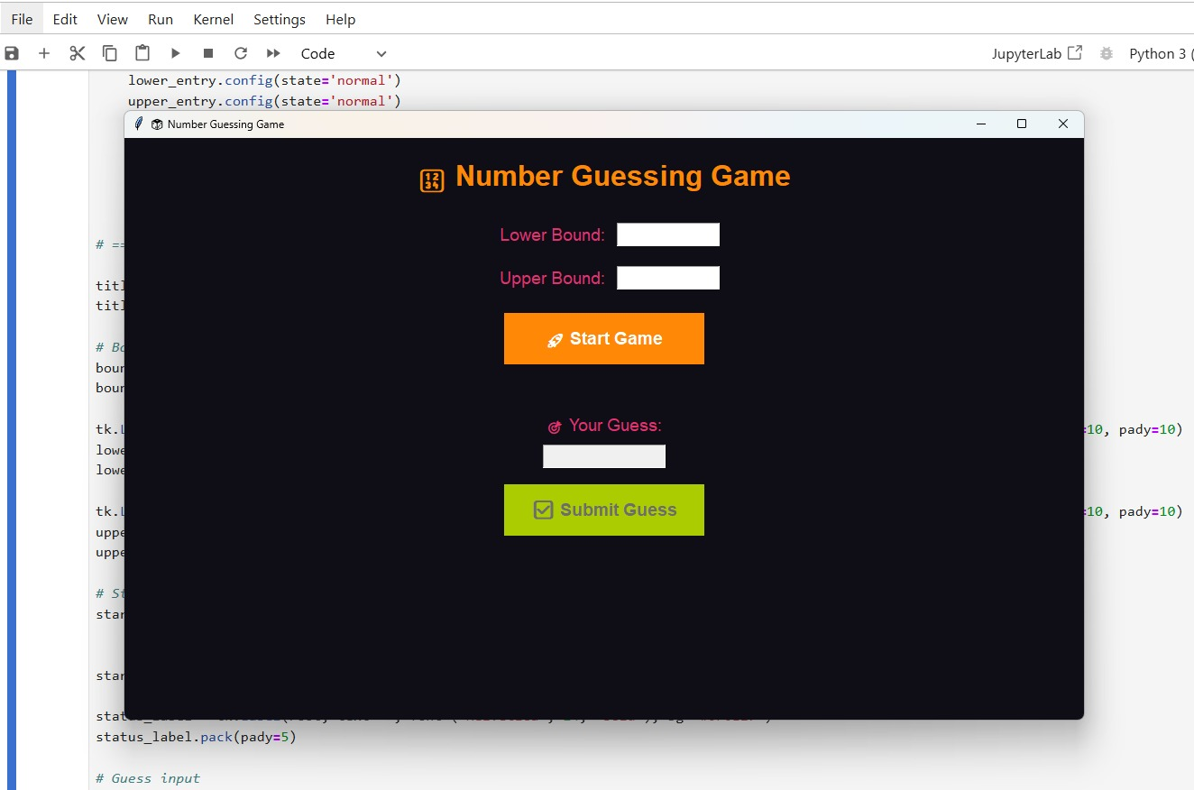

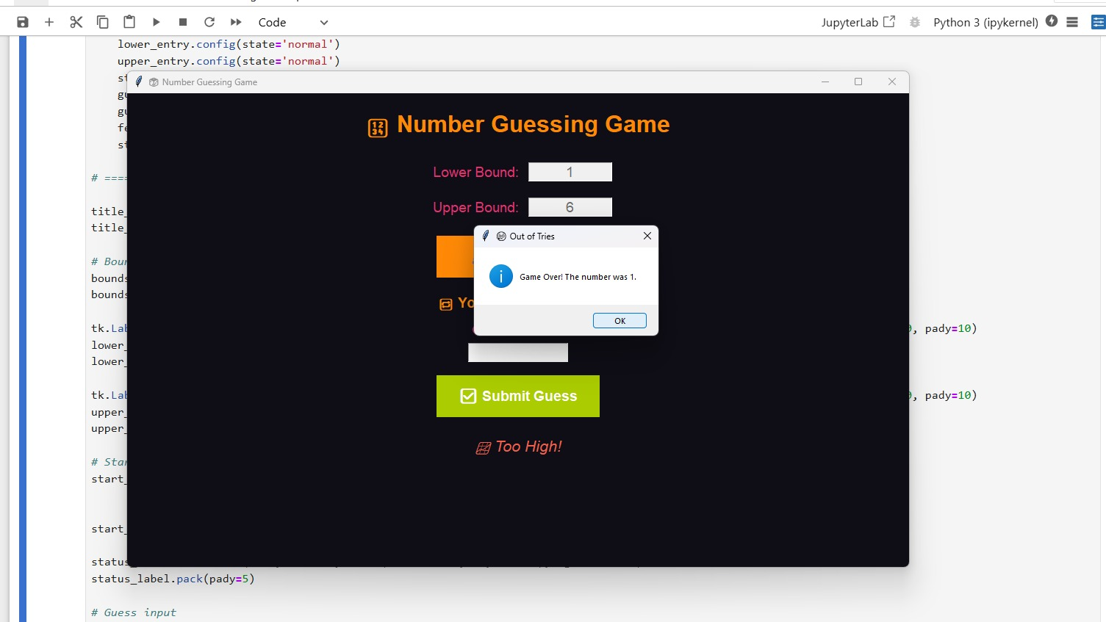

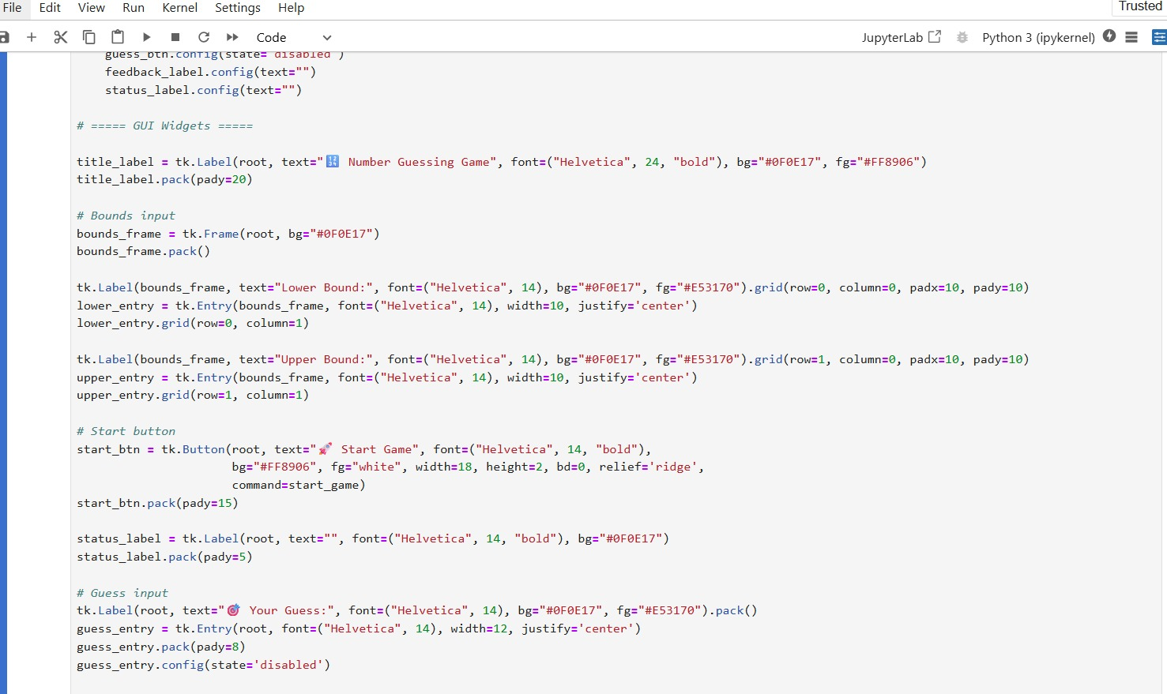

## 

**4)Screen Recorder using Python (PyAutoGUI & OpenCV) -** A high-frame-rate screen recording application that captures and saves desktop activity in real time.  
Built with Python, PyAutoGUI, and OpenCV, it records in .avi format and provides a live preview with a quit option.

Some screenshots of the project done by the trainees:

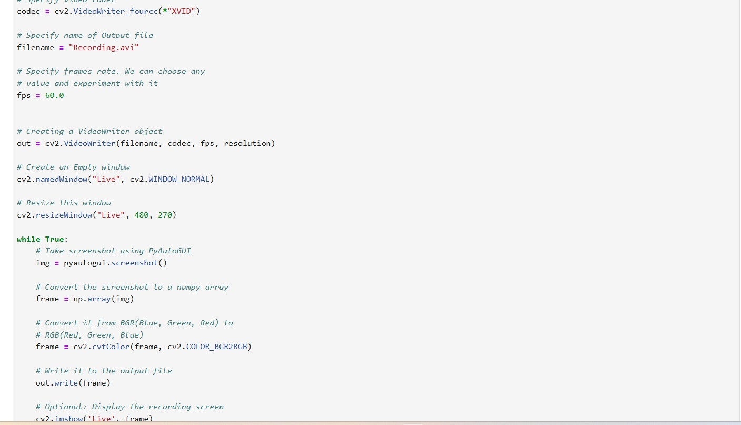

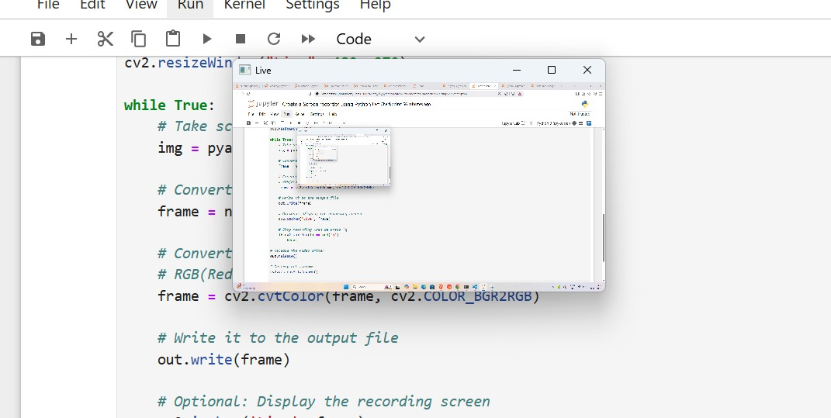

**5)Simple Attendance Tracker using Technologies Used**

**(Python,Tkinter & File Handling)**

**DSC-** This is a simple GUI-based Attendance Tracker built using Python's Tkinter library.

1. Enter the student name and mark attendance (Present/Absent)
2. View attendance records
3. Save attendance to a text file

**Output**-

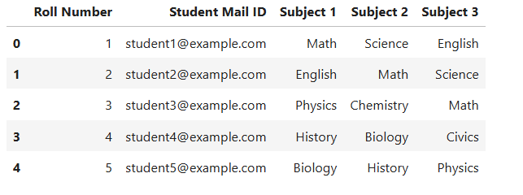

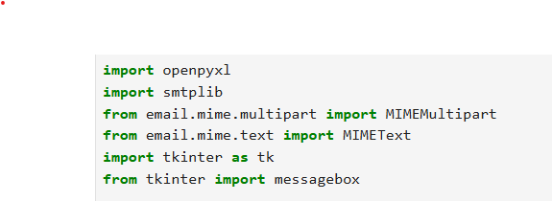

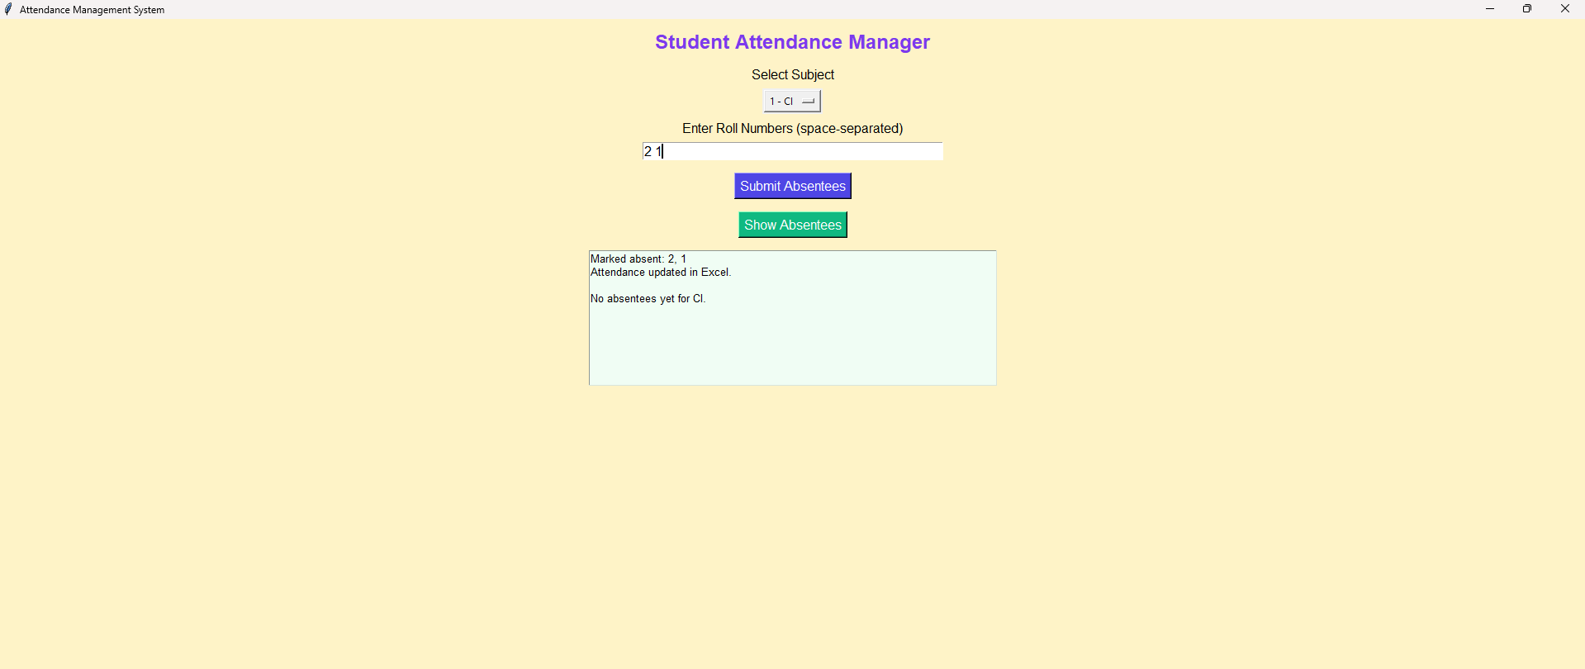

**6)Restaurant Management System (RMS)**

**Frontend Components (Tkinter GUI)**

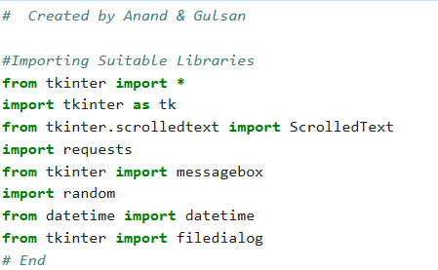

### **Main Window (TK()):**

### Fixed size (1000x900) with title bar showing the restaurant name.

### Frames:

### Main frame: Background layout and styling (bg='#248aa2')

### innerframe1 (Drinks): Contains Checkbuttons and Entry widgets for drinks like Lassi, Tea, Coffee.

**innerframe2 (Foods)**: Checkbuttons and Entry fields for food items like Roti, Dal Makhni, Mutter Paneer.

**innerframe3 (Cost Panel)**: Entry fields for costs - food, drinks, service charge, tax, subtotal, total.

**innerframe4 (Calculator + Bill Display)**:

A simple calculator with digits and basic operators.

A ScrolledText widget to display bill details.

Buttons for Total, Save, Send, Exit, Clear.

2. Backend Components

### Tkinter Variables:

### IntVar() is used to track selection status (checkboxes).

Used to enable/disable related entry fields.

### Command Functions (Not shown in your code, but required):

### lassi_chk(), coffee_chk() etc.: Enable/disable quantity entry when checkboxes are toggled.

total_bills(): Calculate total amount (drinks + food + taxes + service).

save(): Save the bill into a file (usually .txt or .csv).

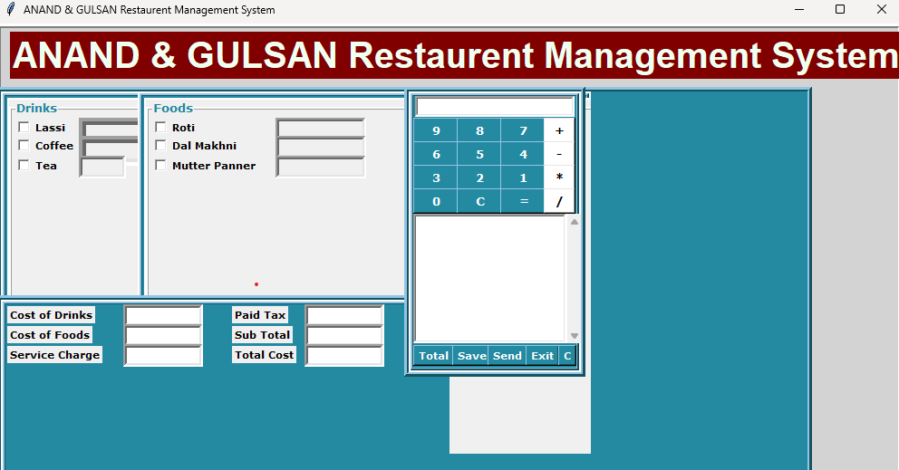

**Send()**: Optional — could be email, SMS, or WhatsApp integration.

**exit()**: Closes the application.

Calculator buttons (one(), plus(), equal(), etc.): Perform calculator operations.

**cleared_bill()**: Clears the bill area.

**Example Functional Flow:**

1. User selects food/drinks using checkboxes.
2. Quantity fields get enabled.

After quantities are filled → press Total.

Total amount is calculated and shown in cost fields and bill display.

Press Save to store the bill, or Exit to close.

**MY ORDER**- you ordered 2 Lassi (₹50 each), 2 Coffee (₹20 each), 1 Tea (₹10), 1 Roti (₹5), 1 Dal Makhni (₹120), and 1 Mutter Paneer (₹150). The subtotal is ₹160, with an added tax of ₹4.5, making the total cost ₹164.5.

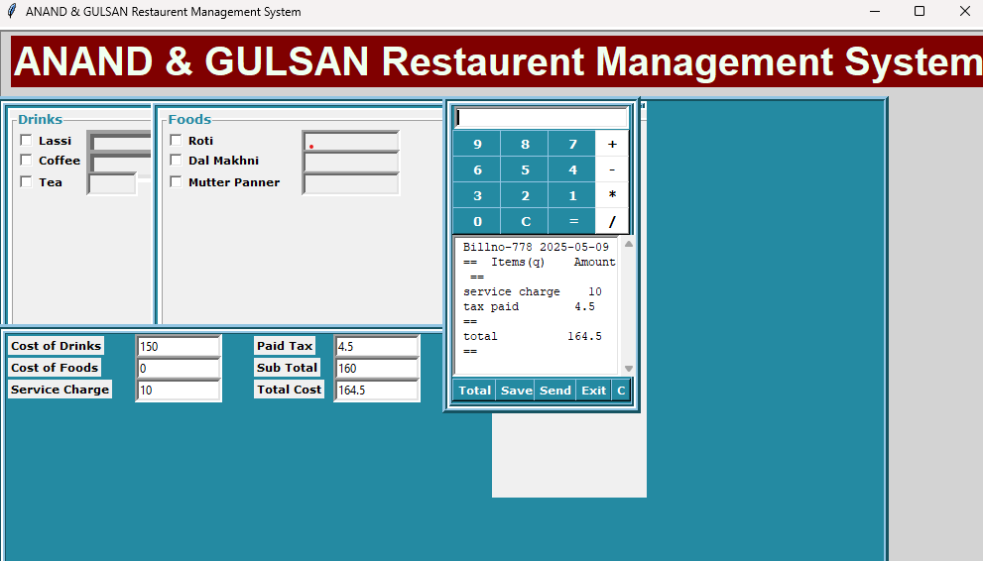

**SEND BILL-**

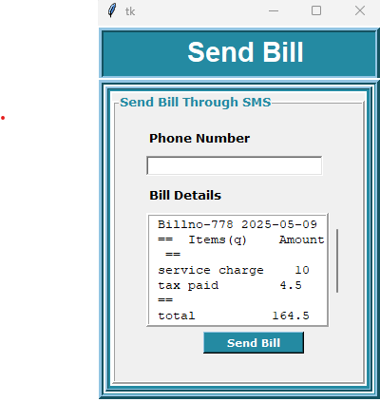

**BILL SEND THIOUGH SMS-**

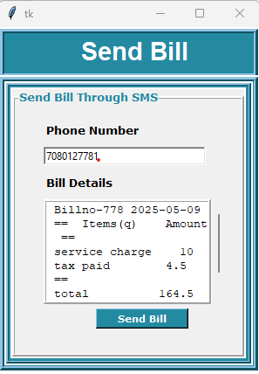

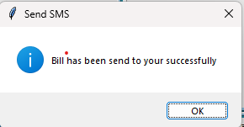

**Menu Card-**

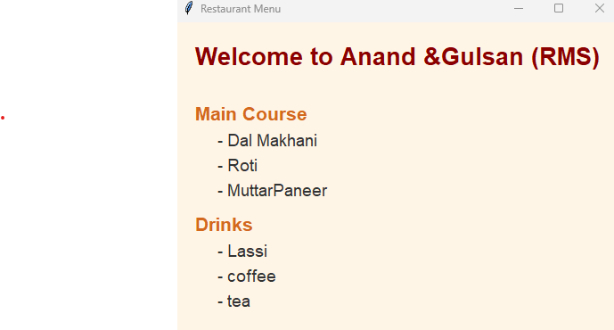

**7)Creating payment receipts using python**-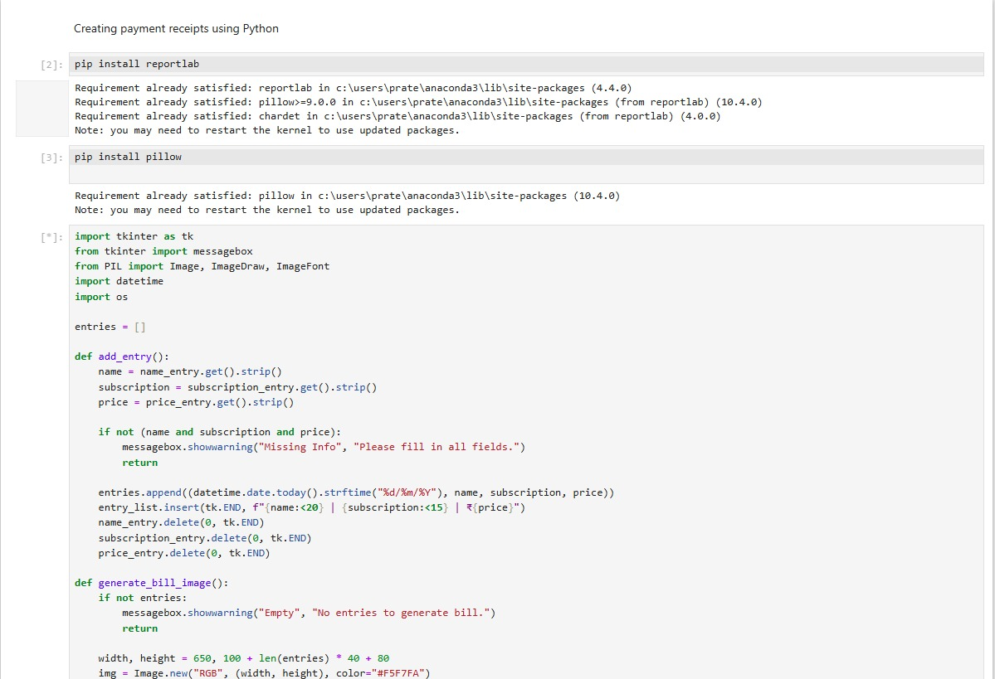This Project create payment receipts using Python means making a bill or slip automatically using a computer. It takes details like name, amount paid, and date, and puts them neatly into a receipt format. The receipt is then saved as a PDF or image file for printing or sharing.

**Output -**

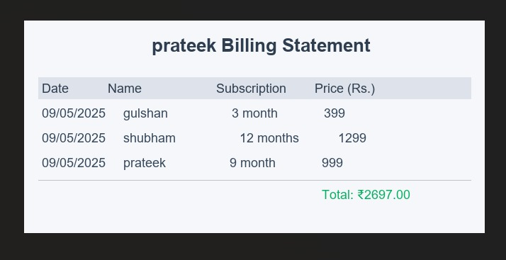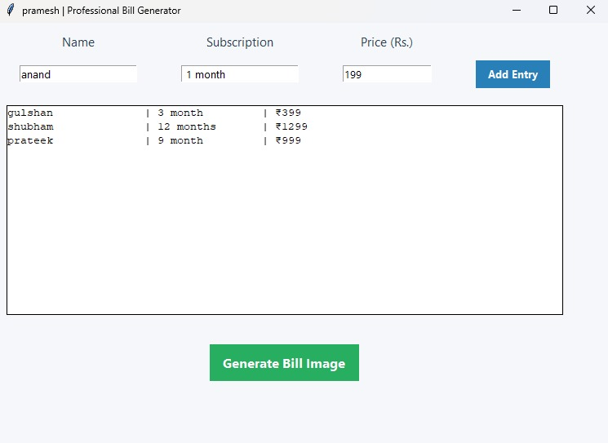

**8)Live weather desktop notification using python-**This project works by collecting real-time weather data from online sources like OpenWeatherMap using an API. It processes the data to extract key details such as temperature, humidity, and weather conditions. Then, it sends a desktop popup notification to keep the user updated.

**Output –**

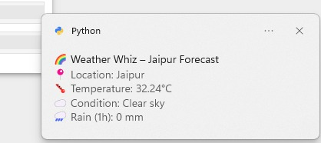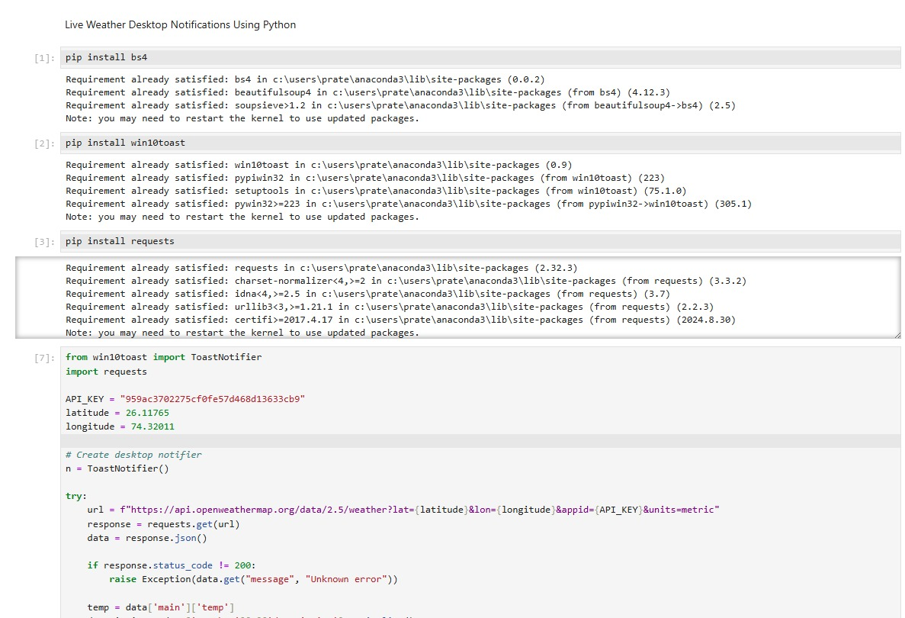

**9)Rock Paper Scissors with tkinter-**This project creates a simple game where the user selects an option (rock, paper, or scissors) through buttons. The computer randomly picks its choice, and the winner is decided based on the game rules. The result is displayed on the screen using a graphical interface.

**Output –**

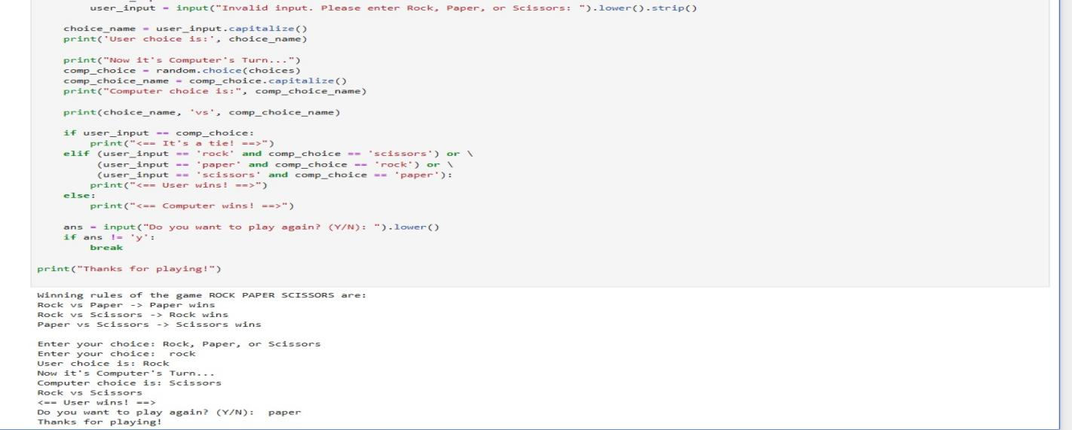

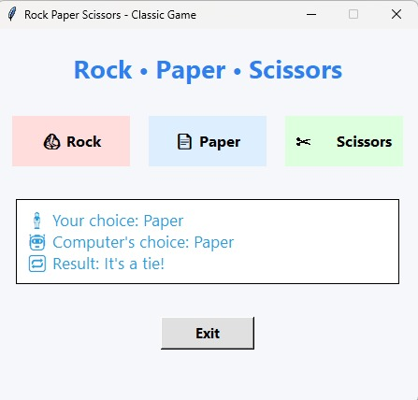

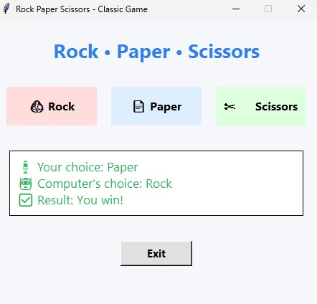

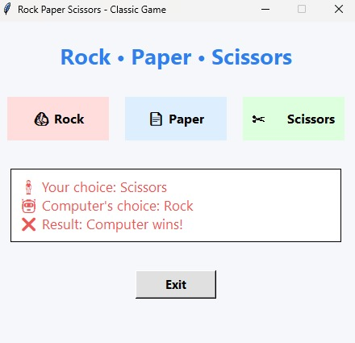

**10)Simple attendence tracker using python -**This project allows users to mark and store attendance data digitally. It records student details along with their presence or absence status, then saves the records in a file such as Excel or CSV. The data can be viewed or updated at any time using a user-friendly interface.

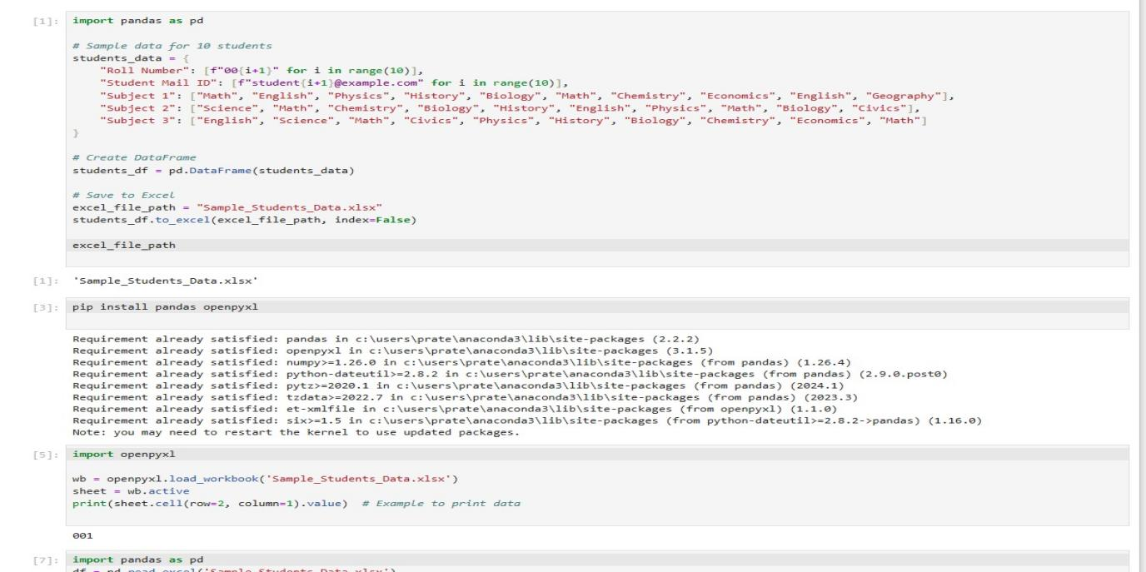**Output –**

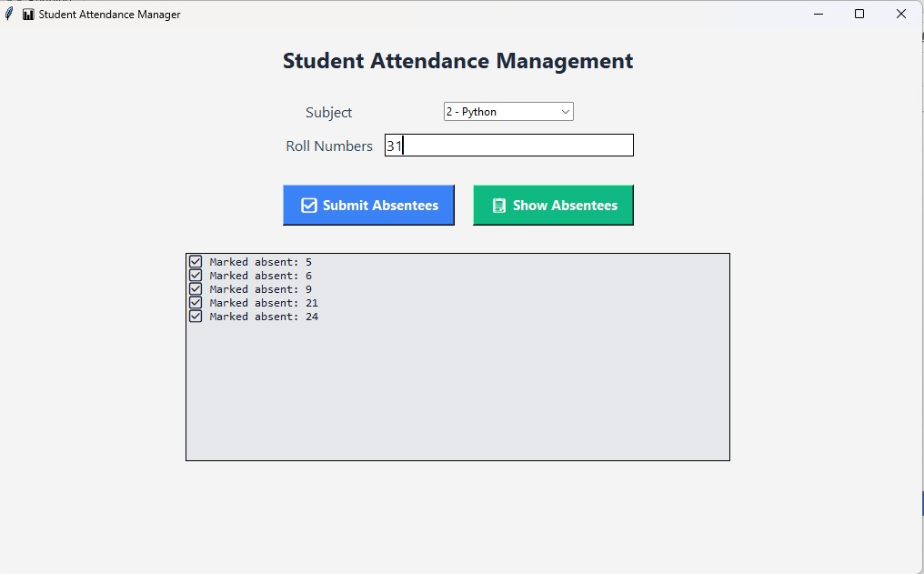

**11)Scraping IMDB movie rating and details Python -** This project fetches data from the IMDb website .The script extracts information such as the movie title, rating, and release year from the webpage's HTML. The collected data is then displayed or stored in a file like CSV for further use.

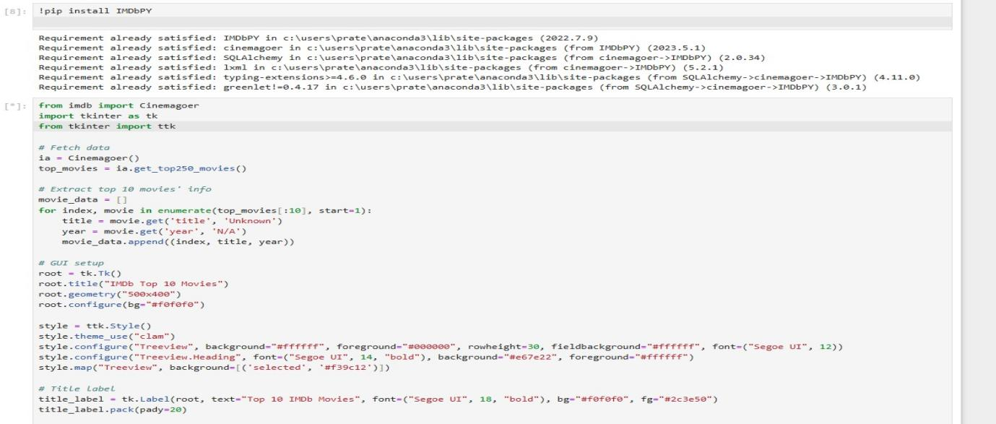**Output -**

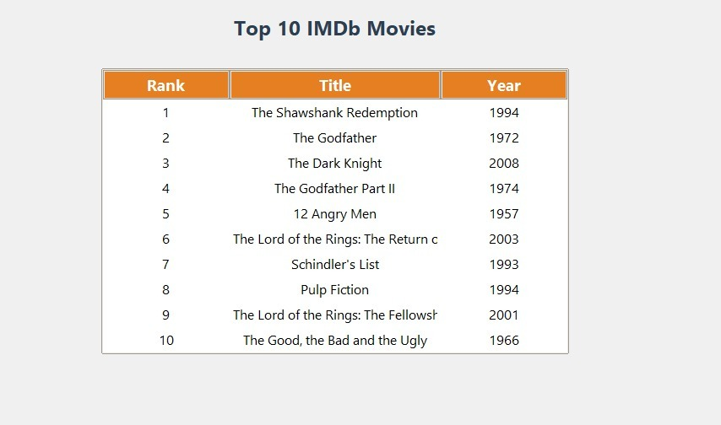

**12)Stock Market Visualizer** - The Stock Market Visualizer is built using Plotly and Dash to display real-time or historical stock data.  
It integrates yfinance for fetching stock prices and allows users to select ticker symbols and date ranges.  
Key features include interactive line charts with moving averages and detailed candlestick charts for technical analysis.

Some screenshots of the project done by the trainees:-

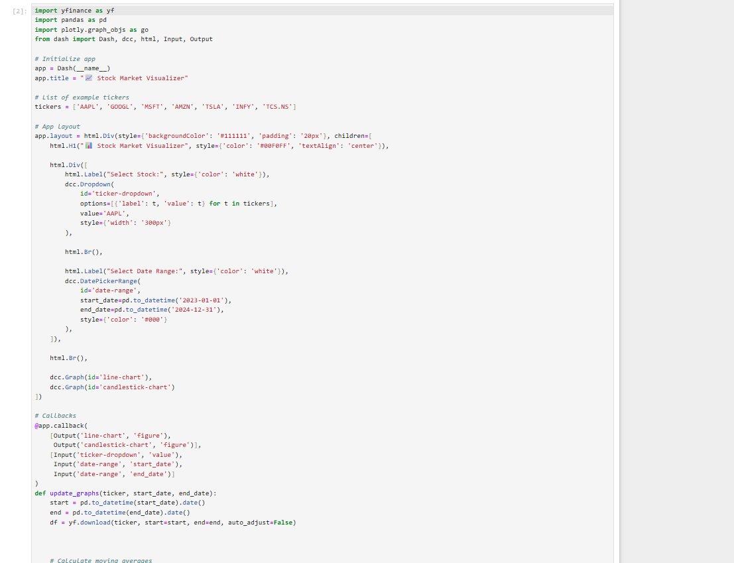

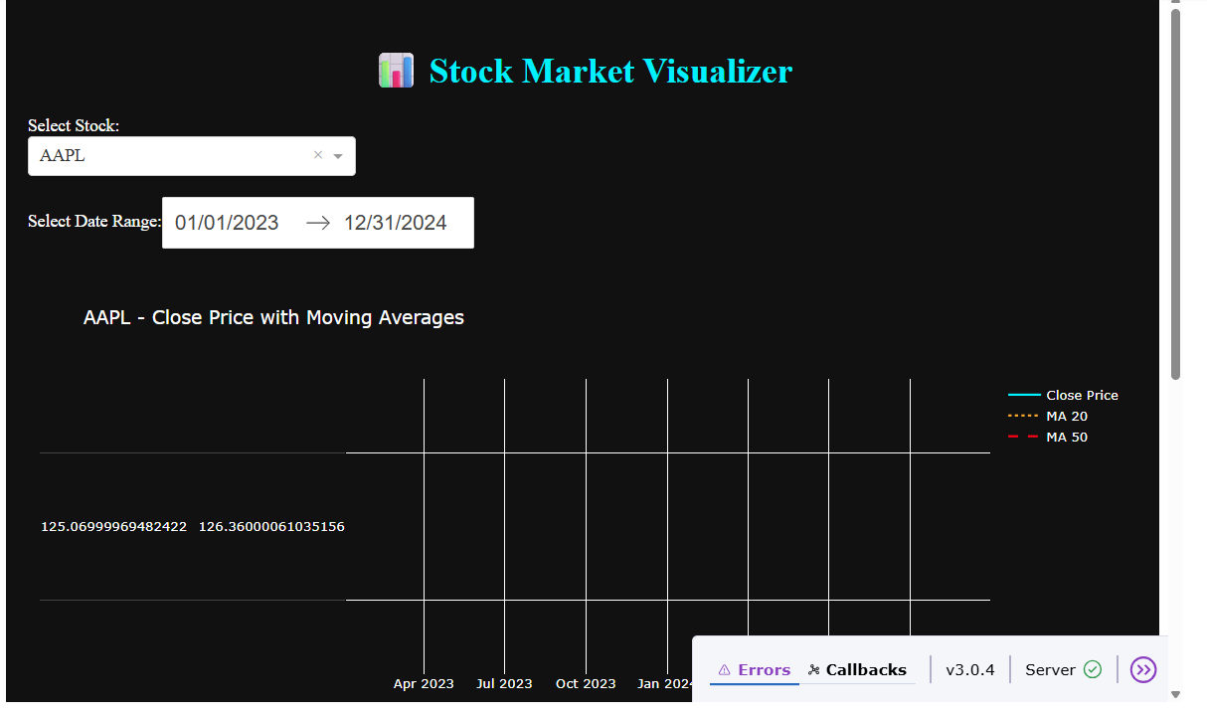

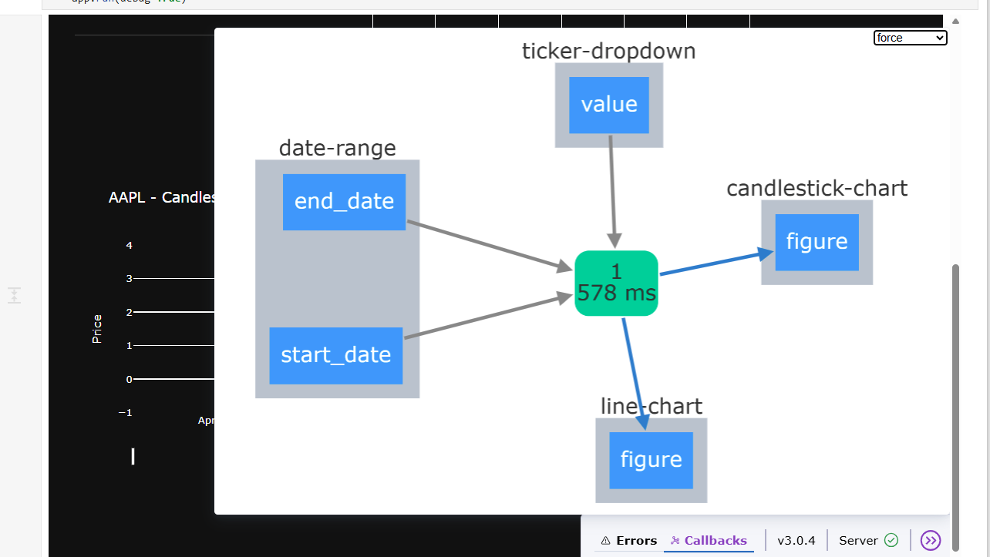

**13)Library Book Management System -** The Library Book Management System manages book inventory and member records using tables like Books, Members, and IssueRecords.  
It allows users to add new books and members, issue and return books, and check book availability in real-time.Additional features include viewing member borrowing history for efficient library operations.

Some screenshots of the project done by the trainees:-

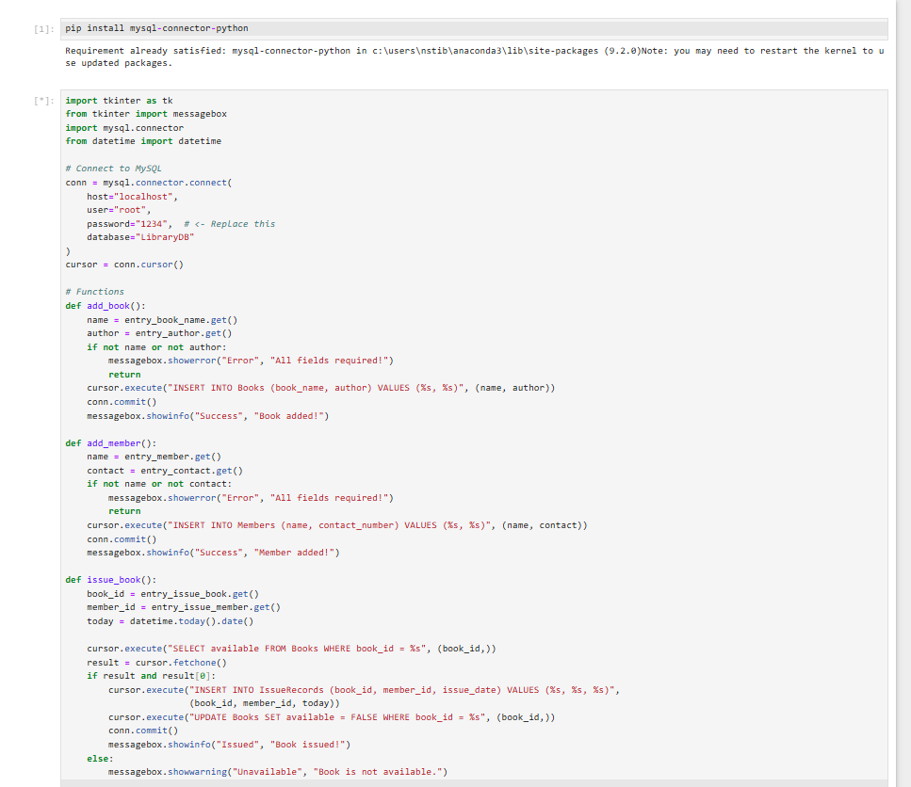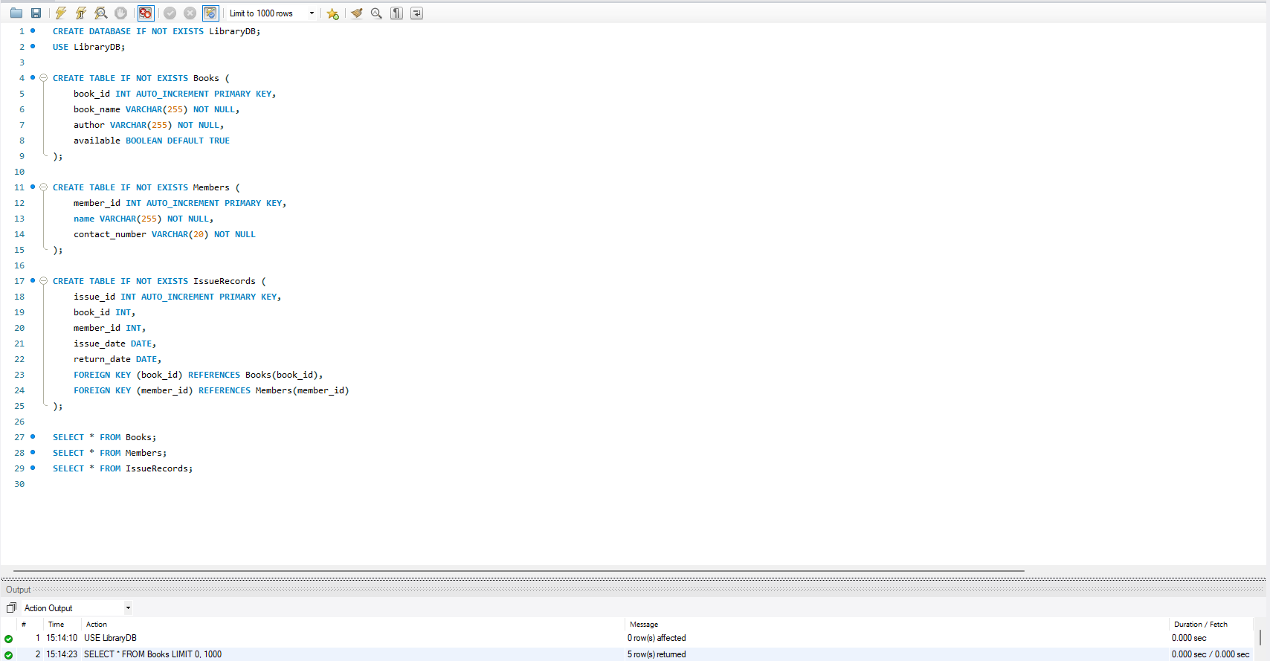

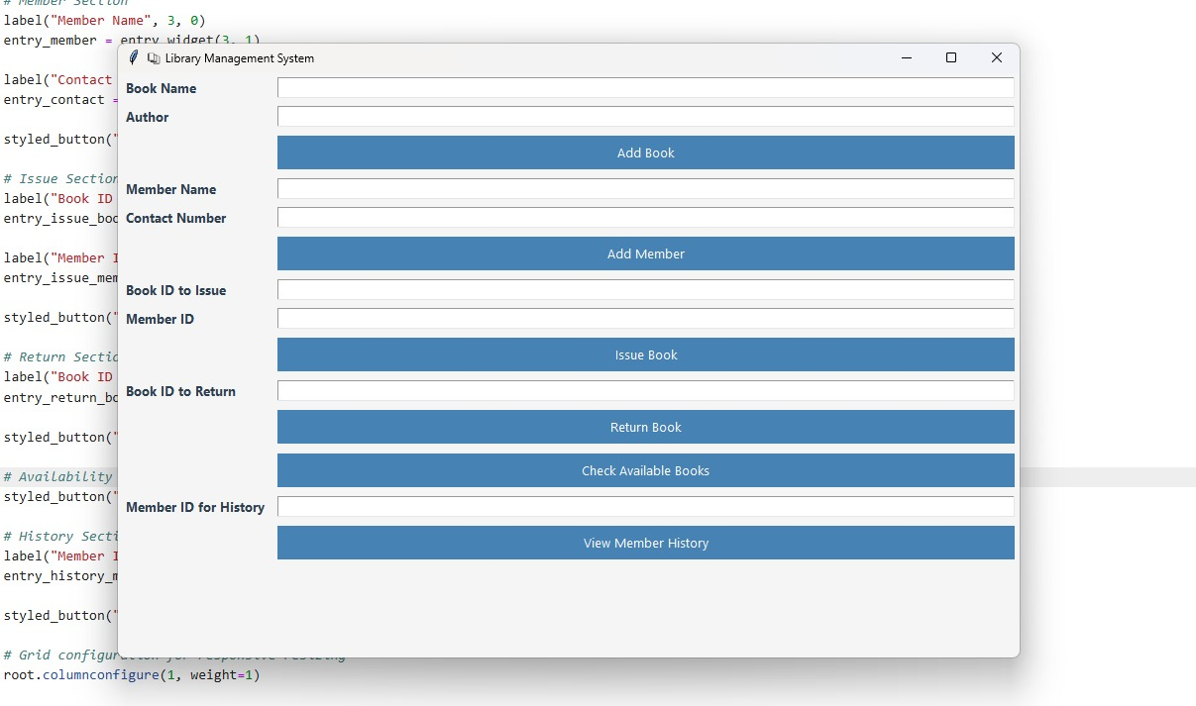

**14)GUI-based To-Do List application -** This project is a simple GUI-based To-Do List application built using Python and PyQt5.It allows users to add, delete, and clear tasks along with selecting a due date using a calendar widget.The interface is user-friendly and includes calendar visibility toggling for better task management.

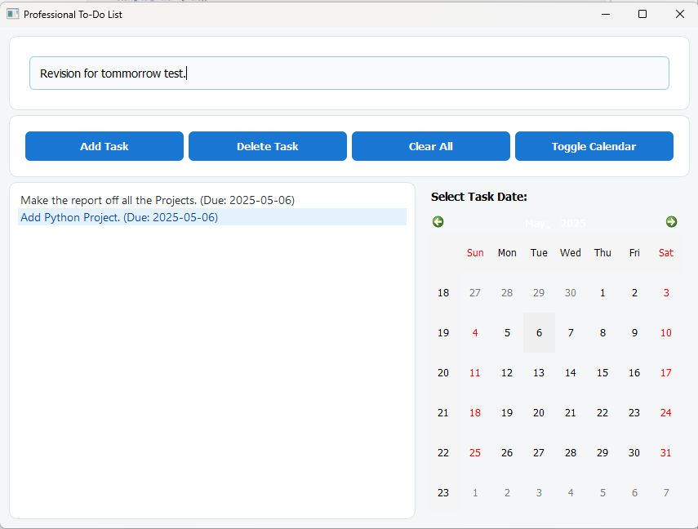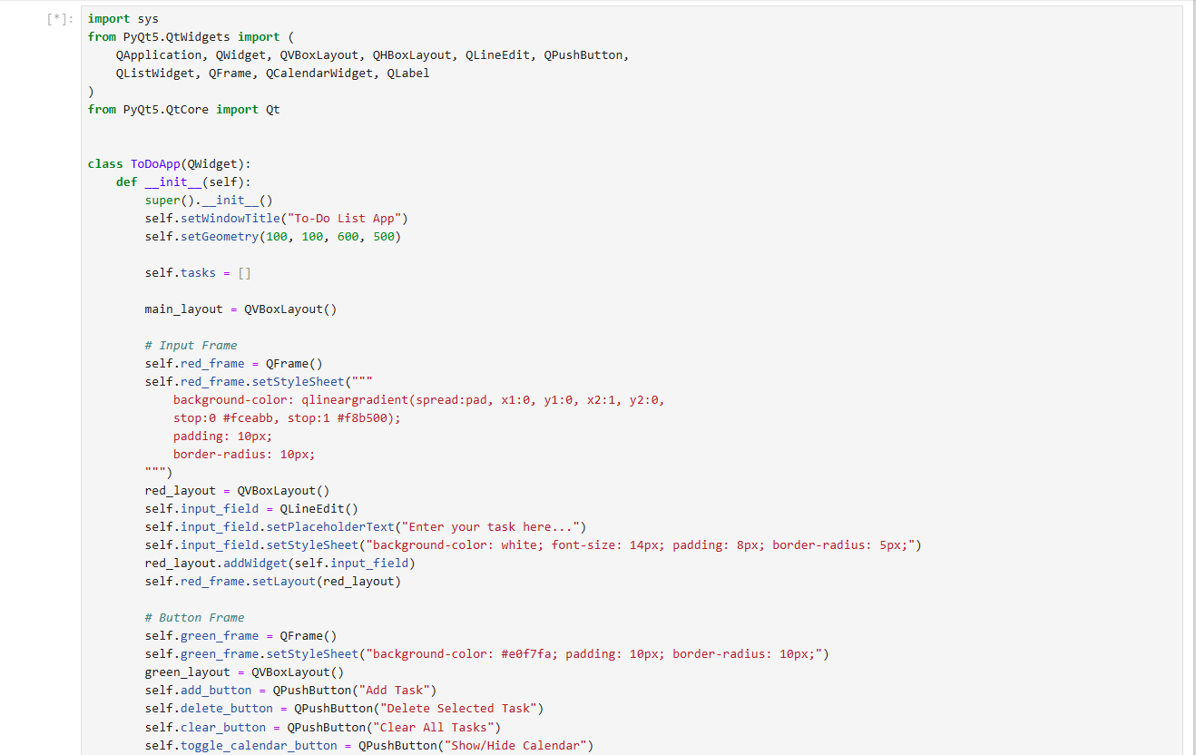

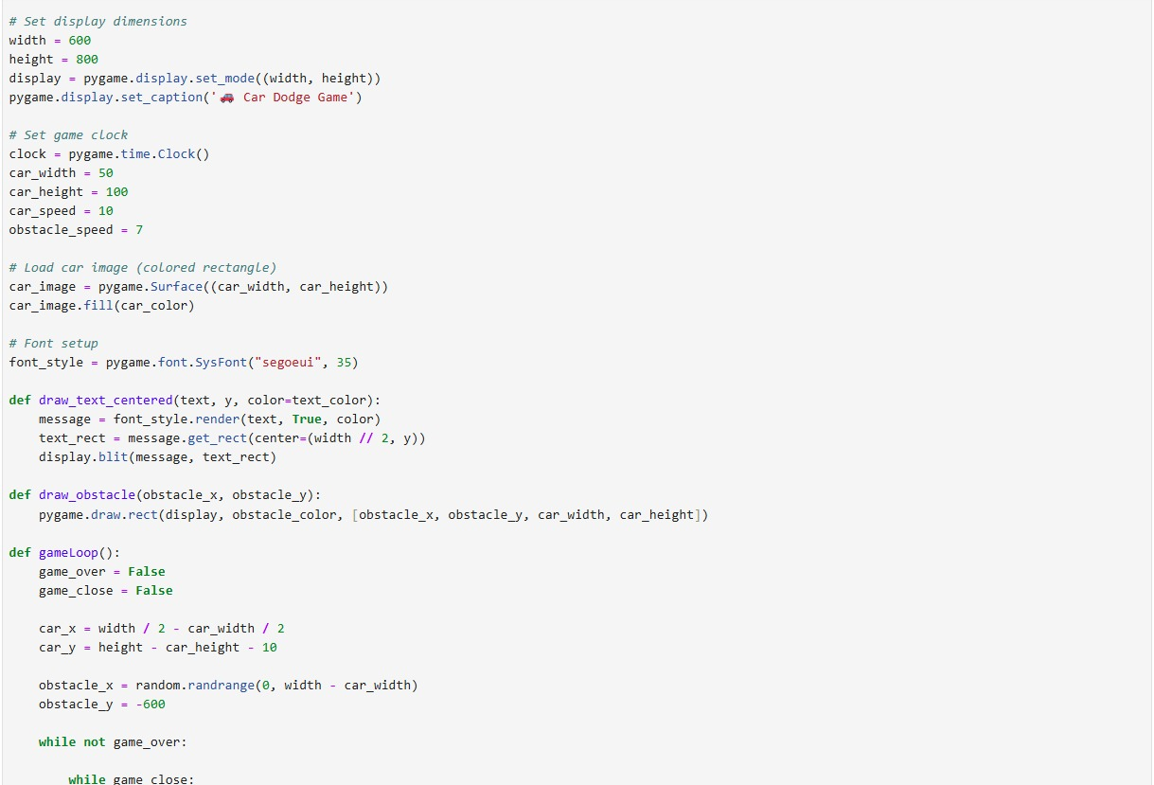**15)Python Game -** This car dodging game is a simple yet engaging arcade-style application built using Pygame. The player controls a car to avoid oncoming obstacles, with increasing challenge over time. It demonstrates foundational concepts in game development such as event handling, collision detection, and dynamic object

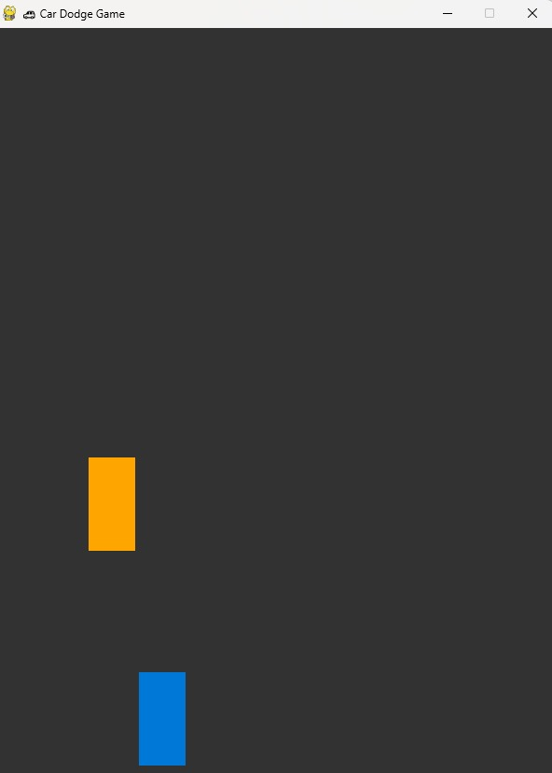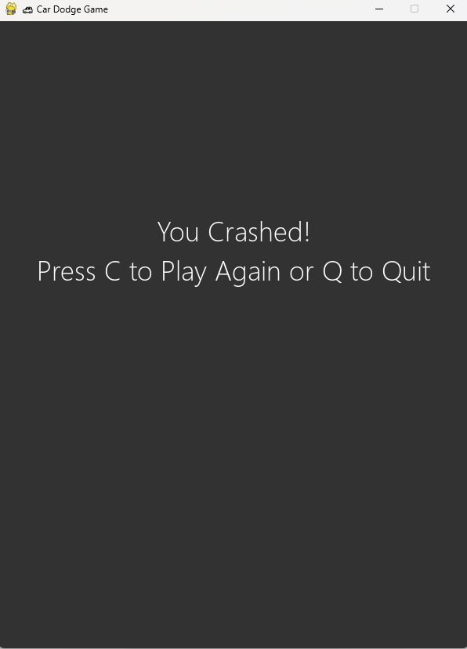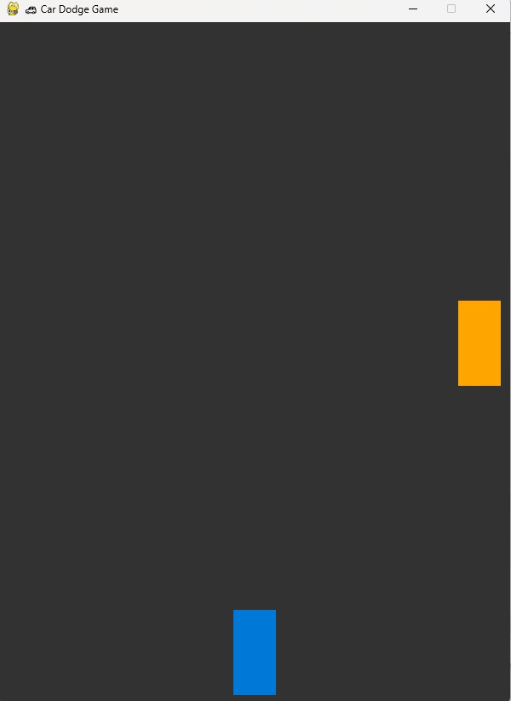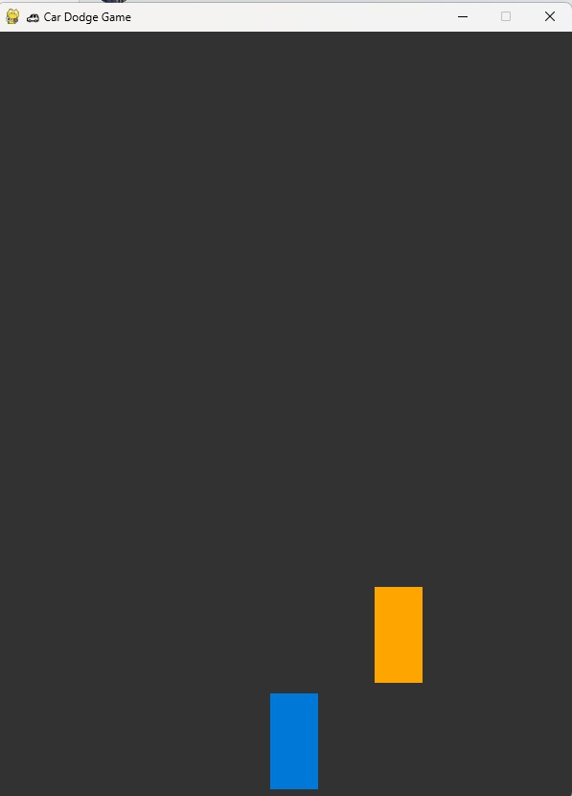

**16)Boutique Management System using Python-MySQL Connectivity**

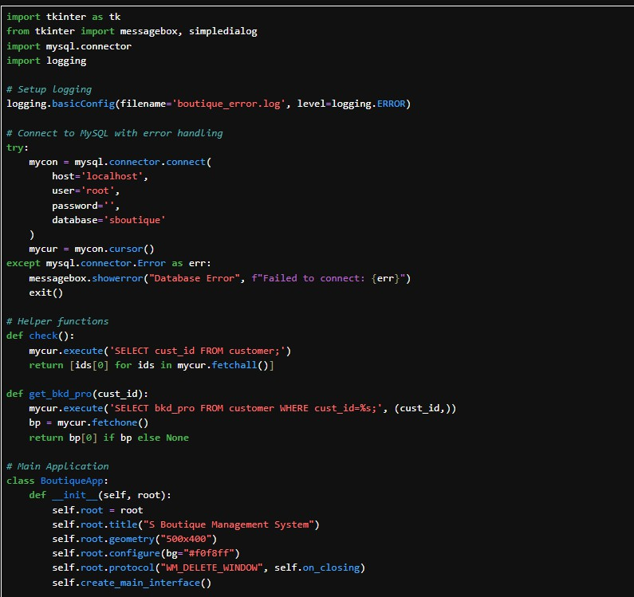

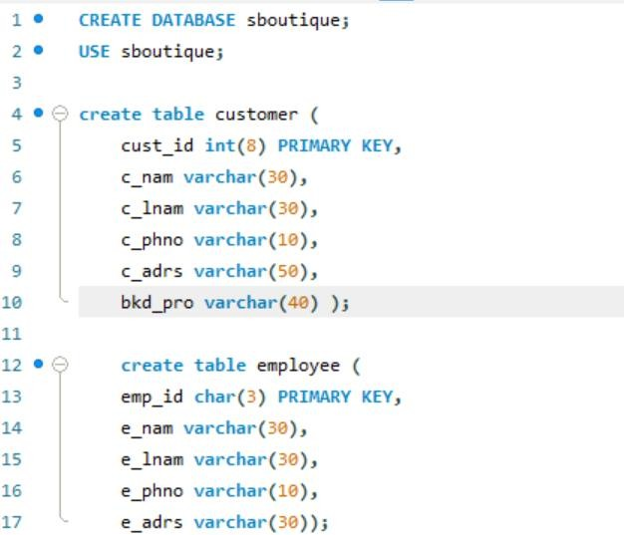

Output:

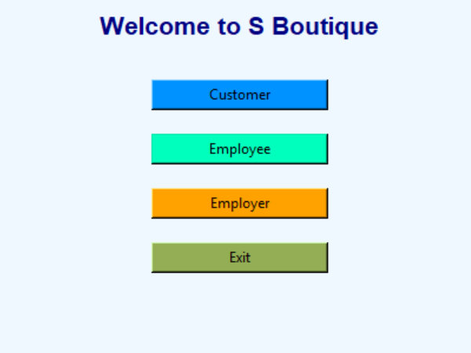

1. **Employee Payment Management System.ipynb**

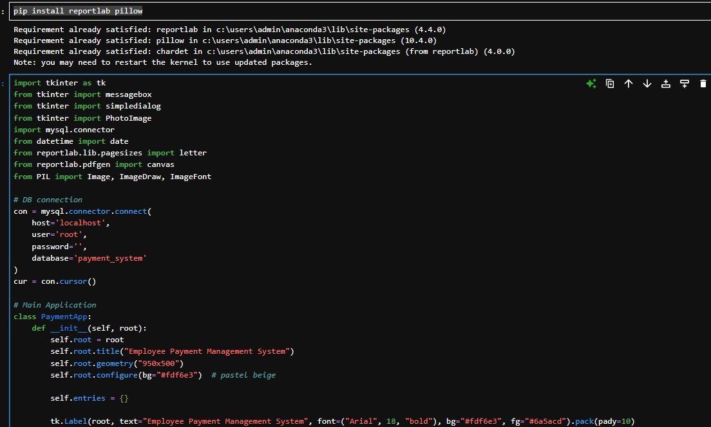

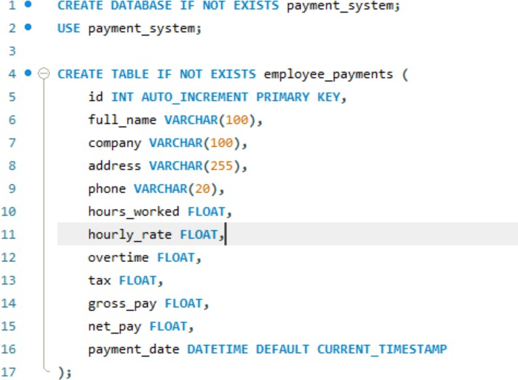

**output-**

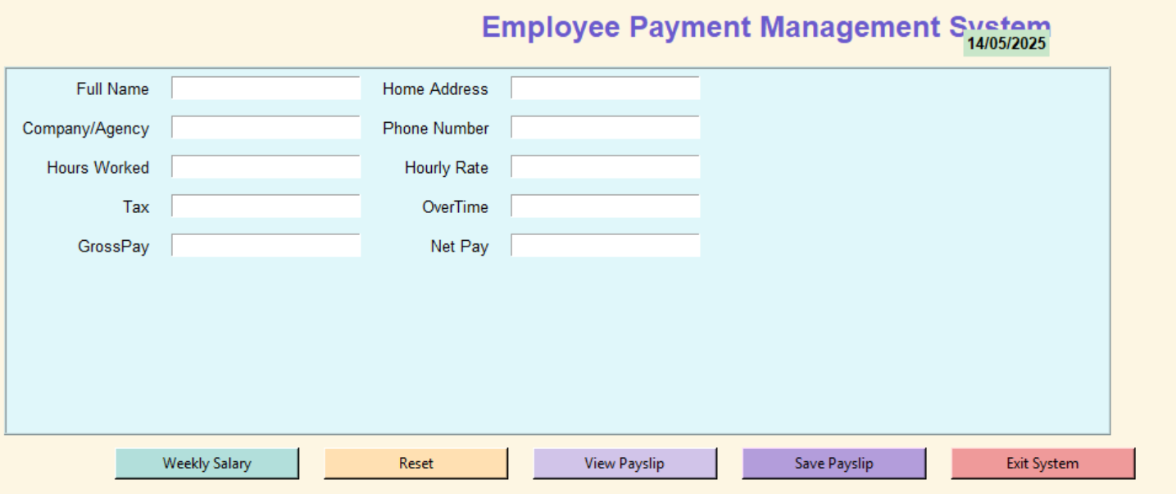

**18) Rangoli Game using Puthon**

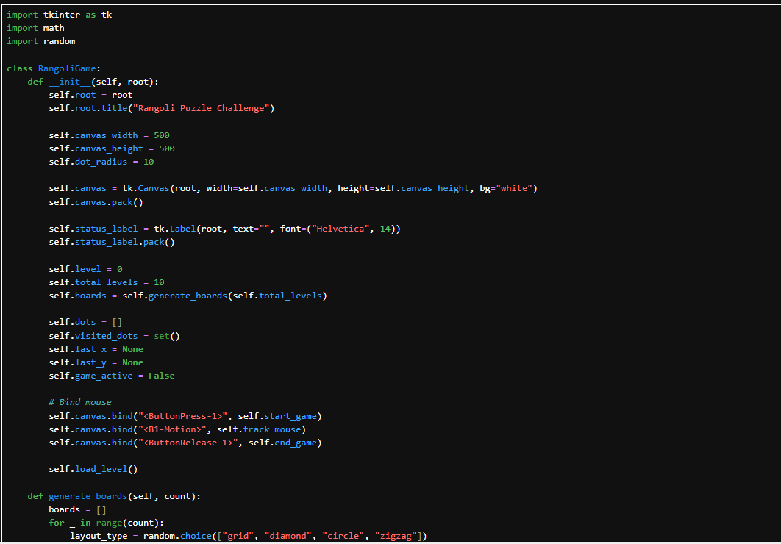

**Output-**

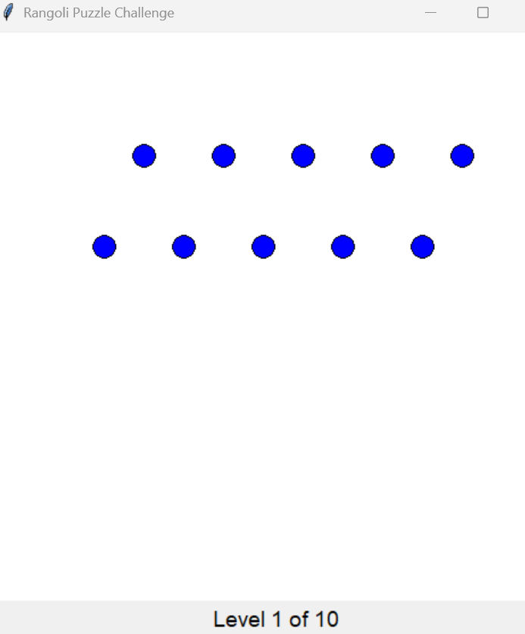

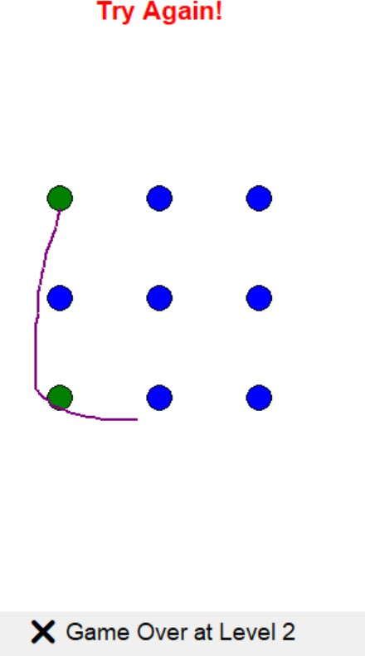

**19)Scientific Calculator Using Streamlit-**This project presents a web-based scientific calculator developed with Streamlit. It supports arithmetic expressions, trigonometric, logarithmic, and exponential functions. The intuitive interface provides real-time computation for educational and practical use.

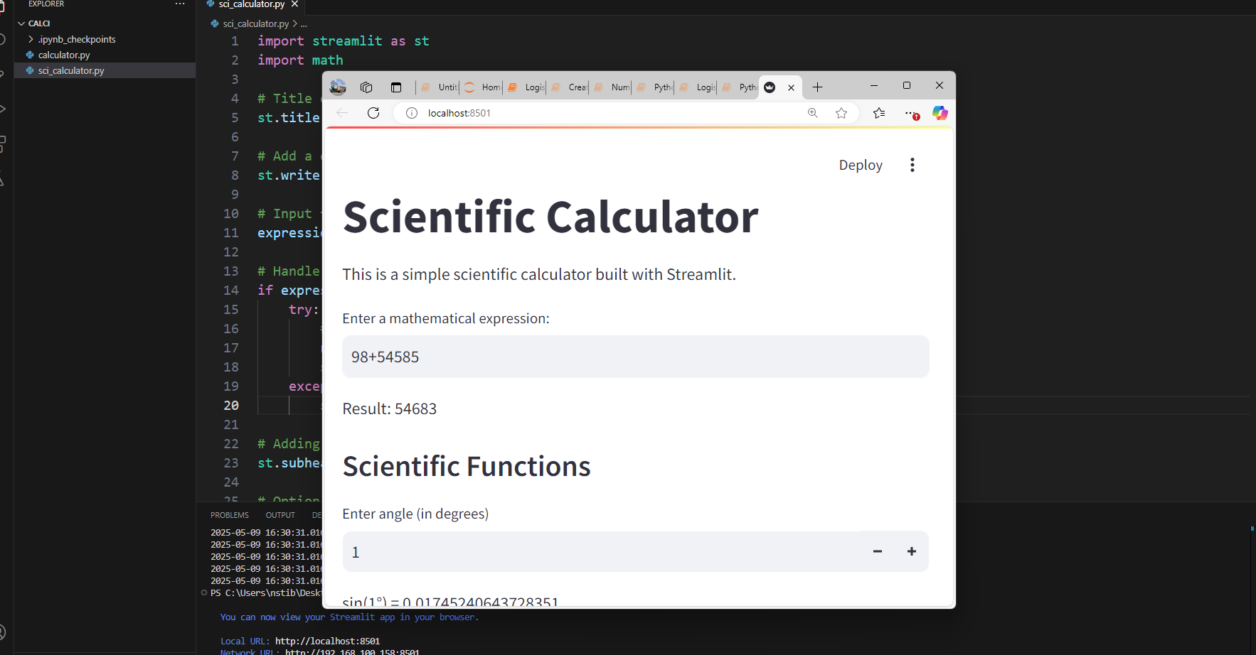

Data Science:

**20)Movie Data Explorer**- This project uses IMDb data to explore movie trends interactively.

It includes a search bar or dropdown to filter by genre or Star cast.

Visualizations include bar plots for genre popularity and box plots for ratings by genre.

Some screenshots of the project done by the trainees:

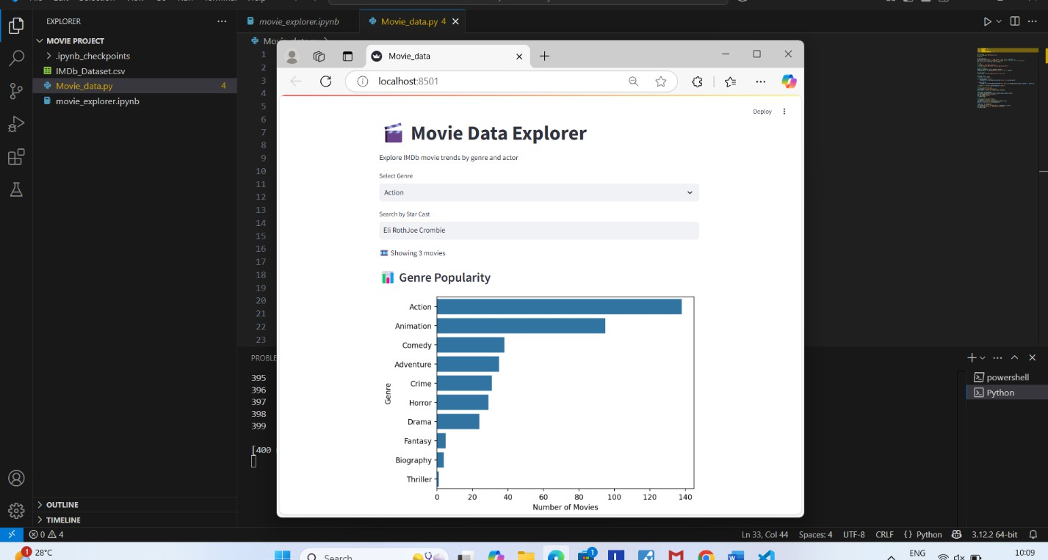

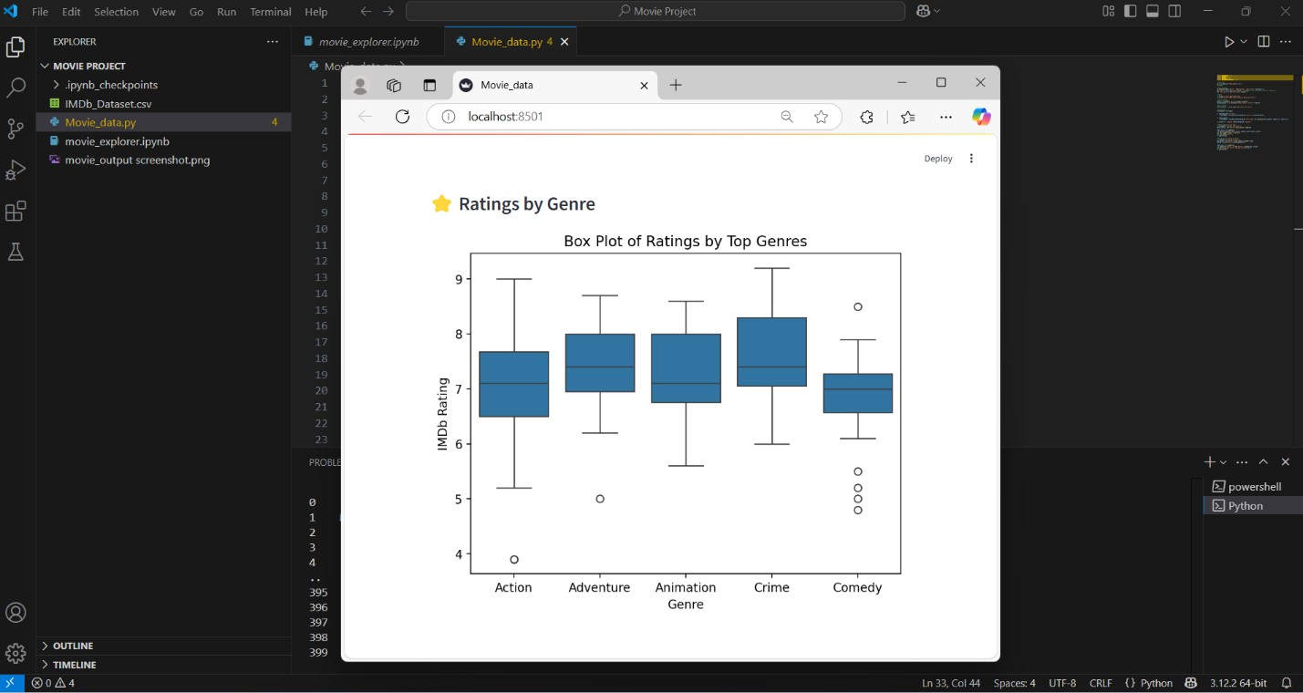

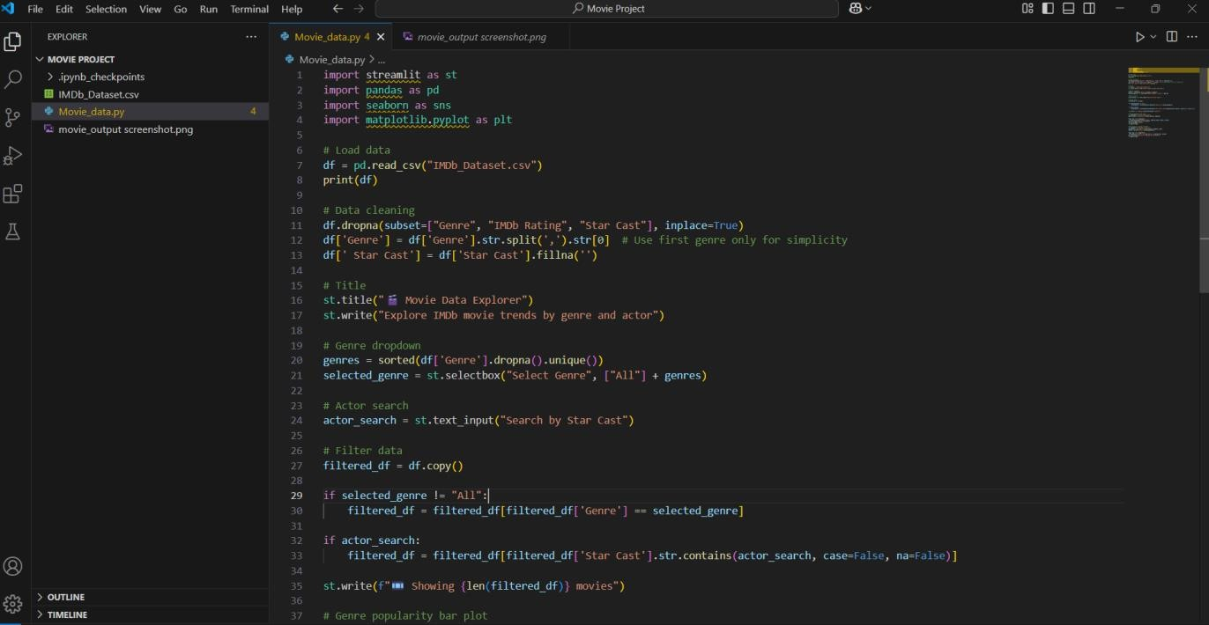

**21)Linear_to_SMVbreat_Cancer**

Support Vector Machine (SVM) is a supervised machine learning algorithm used for classification tasks like cancer detection. The Breast Cancer Wisconsin dataset contains numeric (linear) data representing tumor features. We can use this data to train and SVM model to classify tumors as benign or malignant.

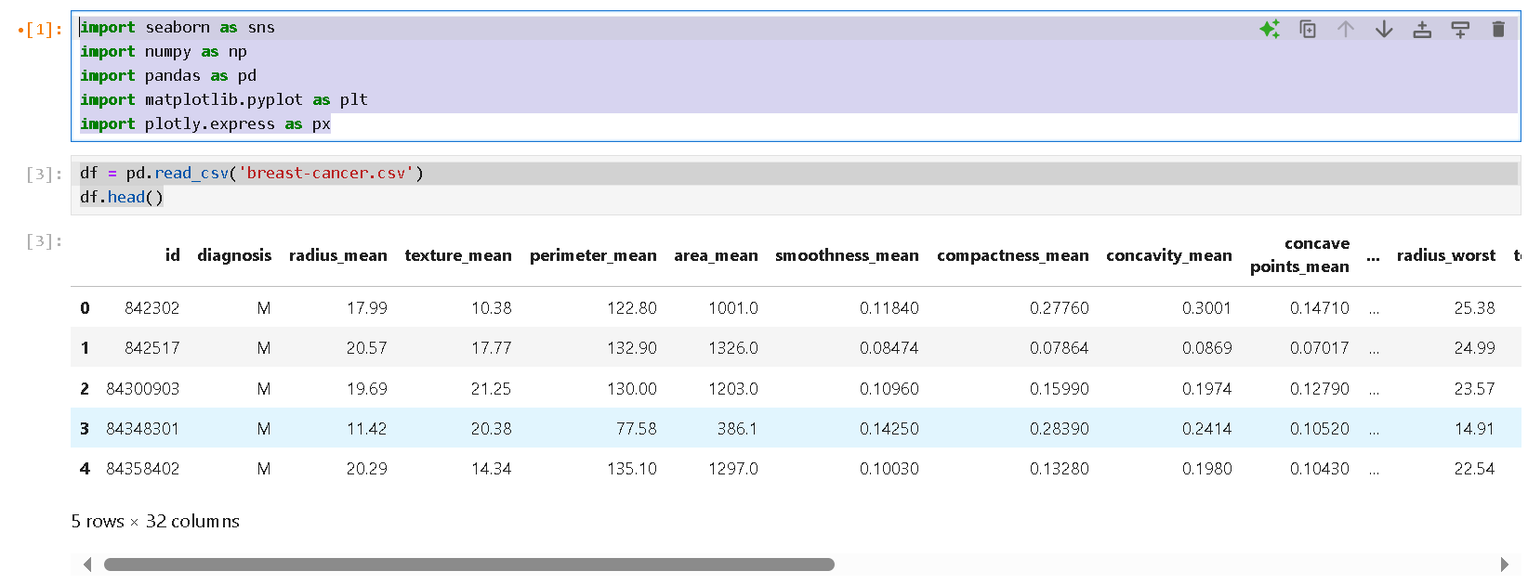

**Output:-**

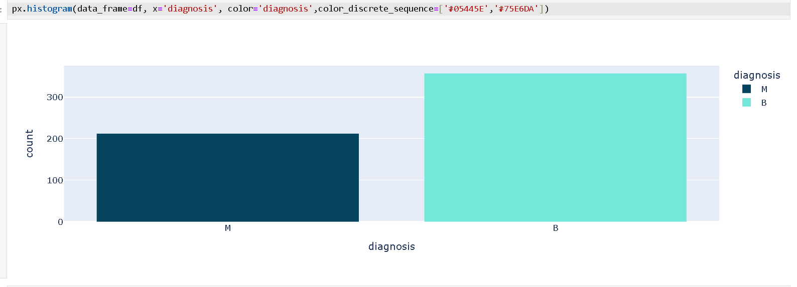

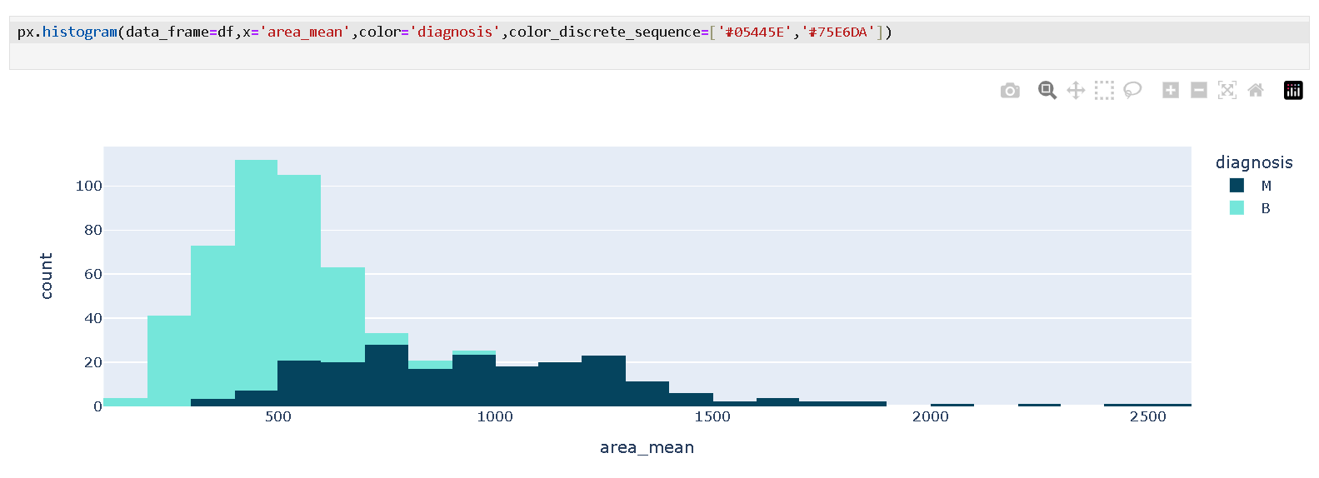

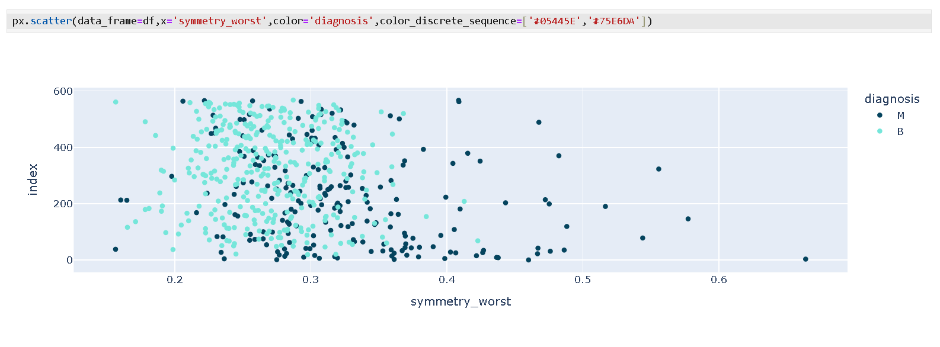

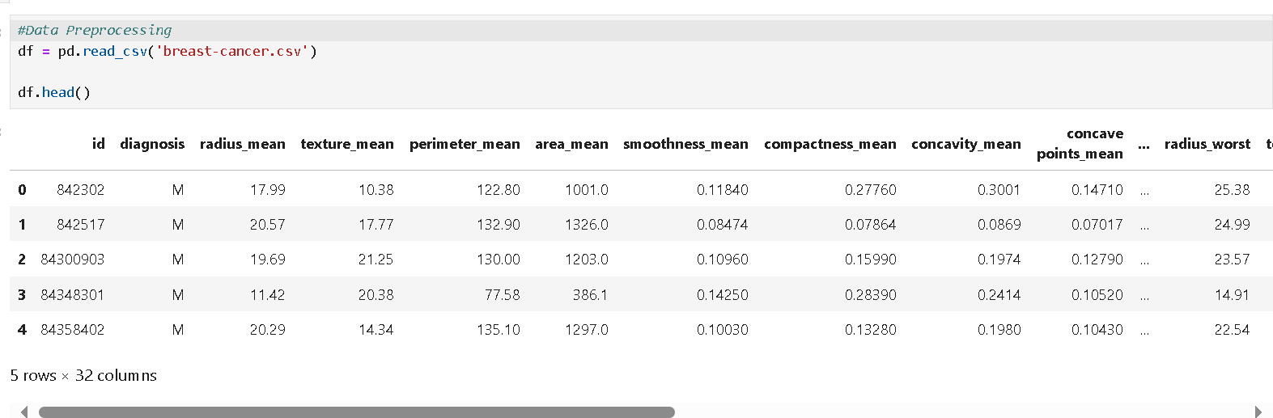 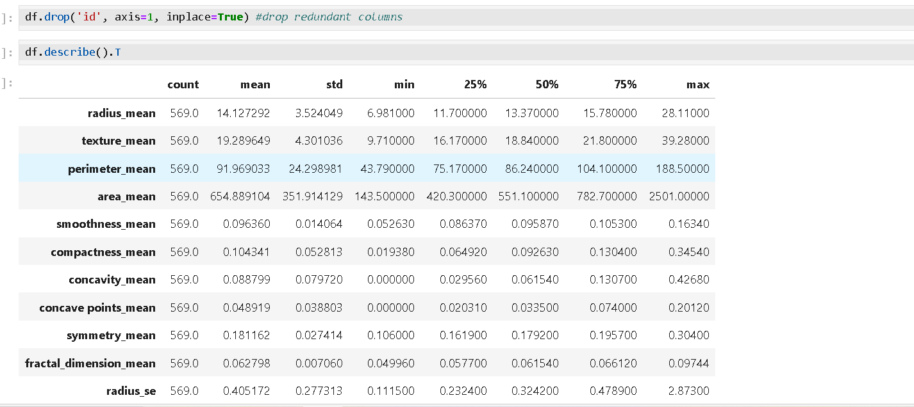

Output-

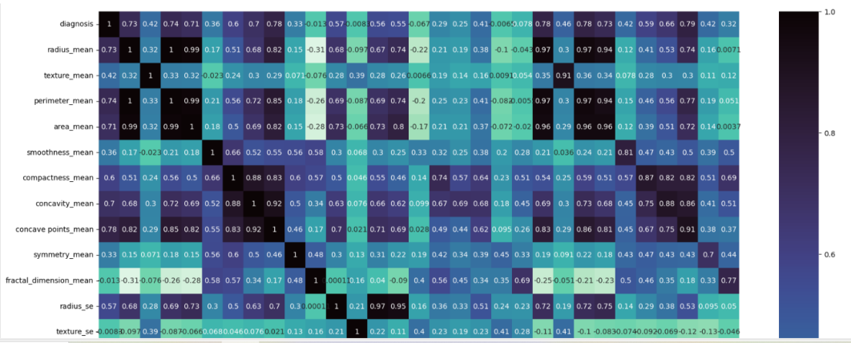

Power Bi:

**22)Movie Dashboard -** This Power BI dashboard presents IMDb movie data using bar, pie, donut, line, and matrix charts. It showcases top-rated genres, yearly movie trends, and average ratings by directors and titles.

Some screenshots of the project done by the trainees:

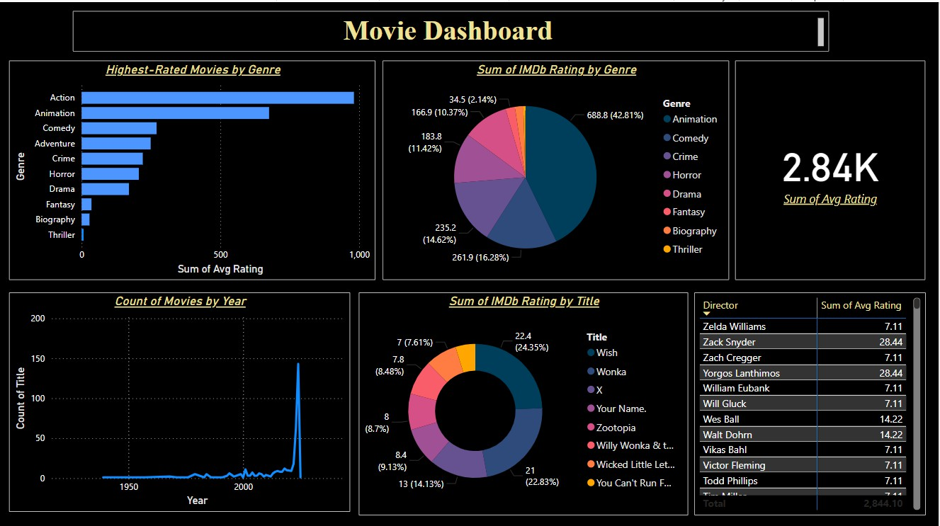

**23)Job Market Analysis Dashboard -** This dashboard provides a visual overview of global job opportunities by company, location, job title, qualification, and salary range. It uses maps, bar charts, and pie charts to show hiring trends, qualification demand, and salary insights. The data covers over 1.62 million jobs across various industries and roles.

Some screenshots of the project done by the trainees:

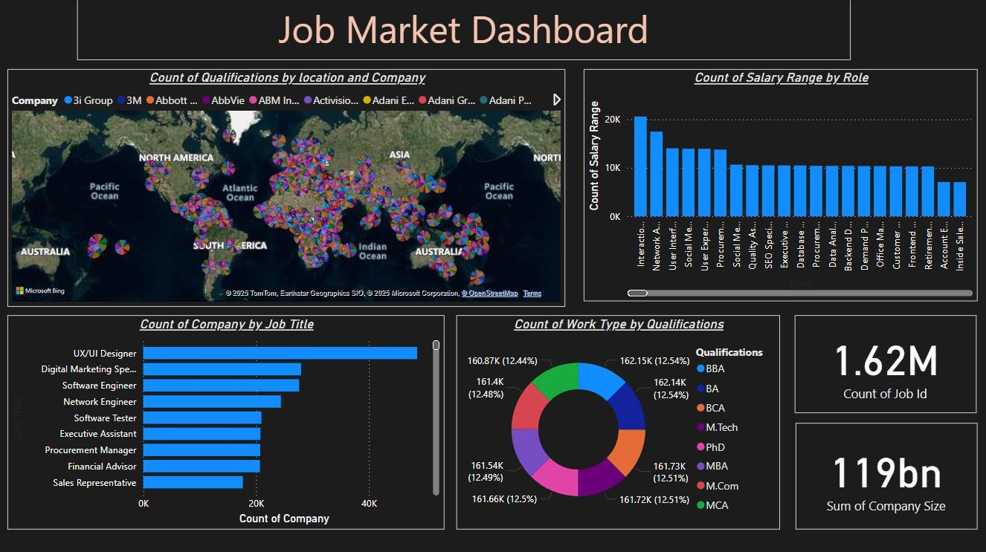

**24)Supermarket Sales Dashboard -** The Supermarket Sales Dashboard provides interactive visual insights using free datasets like SampleSuperstore.It features KPIs, date slicers, and maps to analyze sales by product category and region.Users can track monthly sales trends and compare profit versus sales for better business decisions.

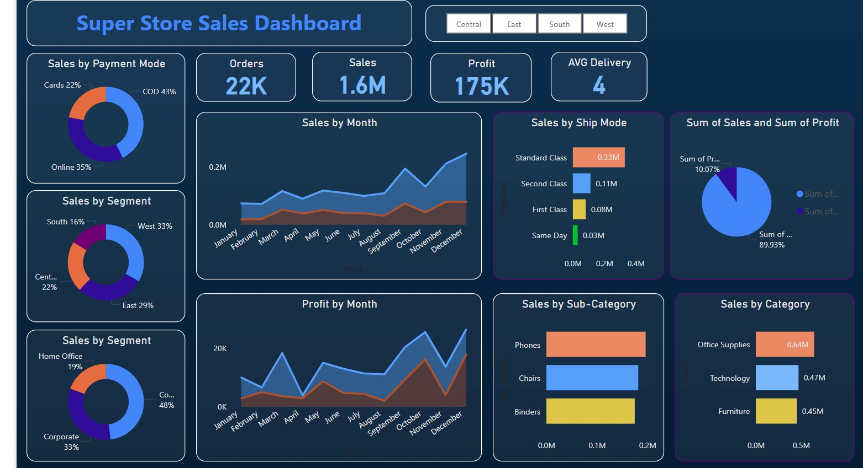Some screenshots of the project done by the trainees:

### 

Machine Learning:

**25)Breast Cancer Prediction using Logistic Regression -** This project shows a binary classification model that predicts breast cancer presence using clinical features from the UCI dataset.  
Built with Python and Scikit-learn, it uses logistic regression and visualizes results via a confusion matrix.

Some screenshots of the project done by the trainee

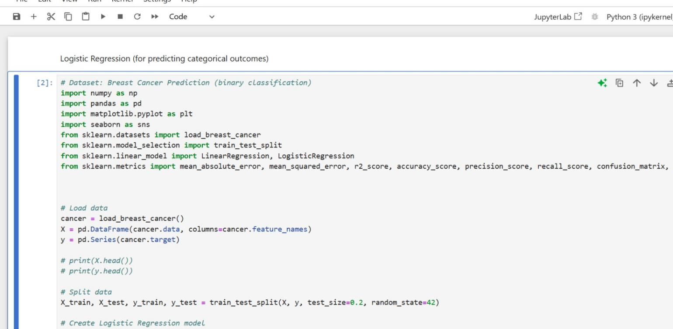

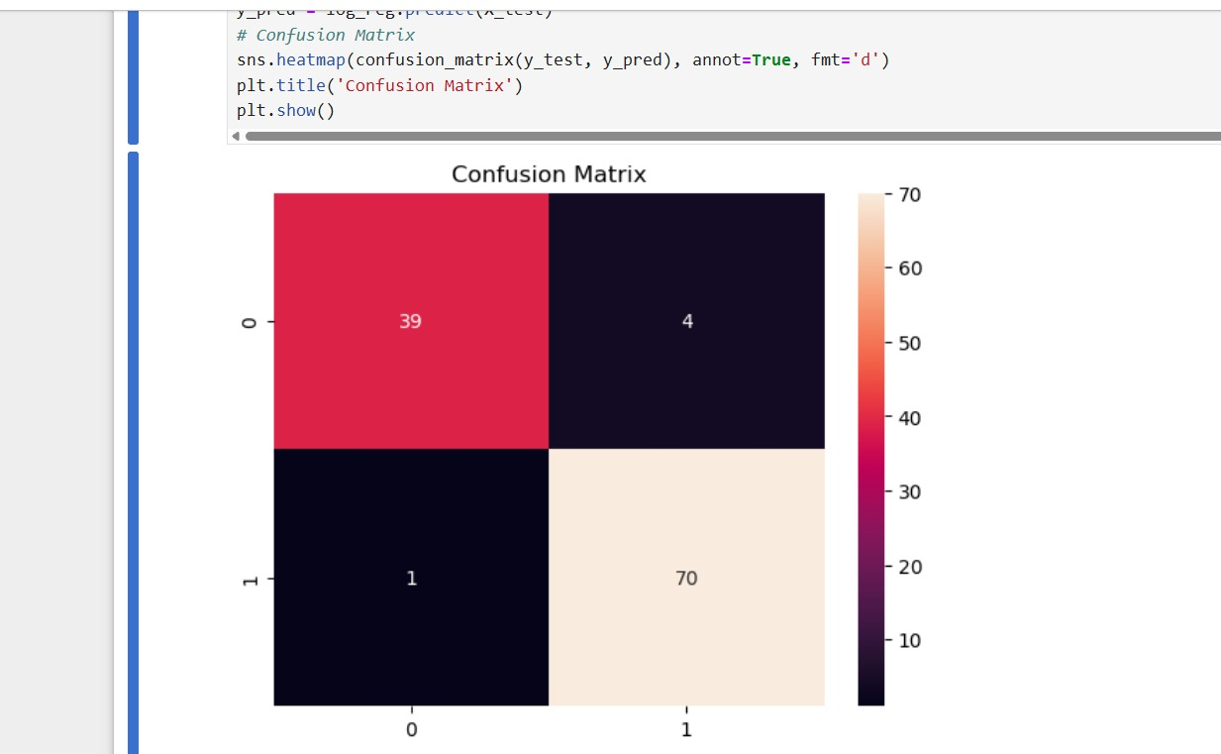

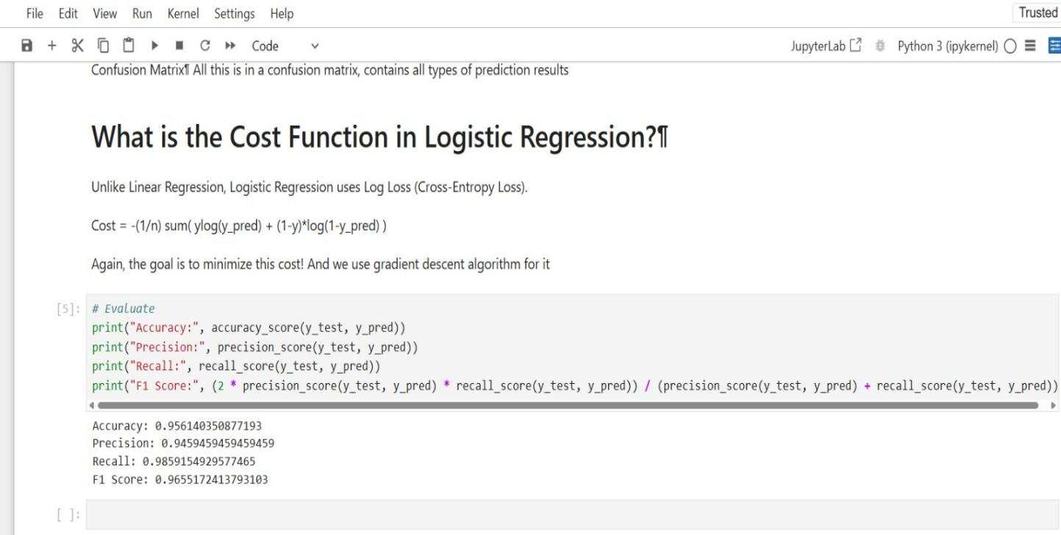

**26)Linear Regressionon Study Hours**

In this project, we used linear regression to predict student scores based on the number of study hours. The dataset contains study hours and corresponding exam scores. The model helps show the direct linear relationship between study time and performance.

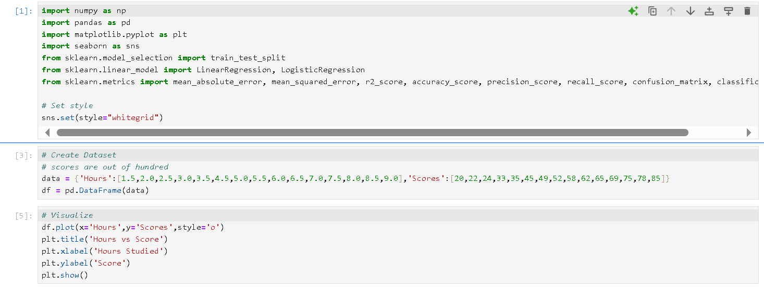

Out put:

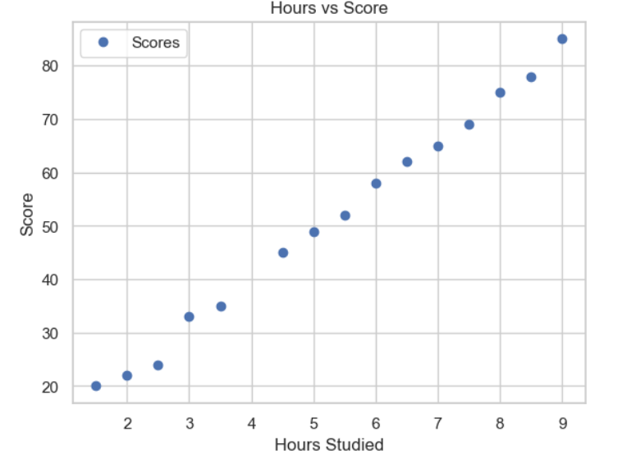

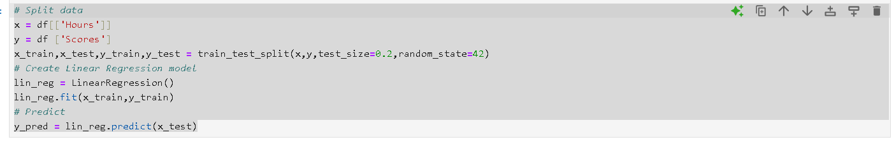



Out put

